

Southern California Edison
CS Re-Platform Project

Process 30 CIM-CS-17 Front Office
Customer Interaction Management
Business Process Design
Version 2.7

Table of Contents
1 Business Process Overview 4
1.1 Current Pain Points for Southern California Edison 4
1.2 Responsible Parties 4
1.3 Document Control 4
1.4 Terminology 5
2 Business Process Design 6
2.1.1 Front Office – Systems Overview 6
2.1.2.1 UI and General Navigation 6
2.1.2.2 UI and General Navigation - Home Page 8
2.1.2.3 UI and General Navigation - Feed 9
2.1.2.4 UI and General Navigation - Follow, Favorites, Flag, Hashtag and Posting an Update 10
2.1.2.5 UI and General Navigation - Notifications 11
2.1.2.6 UI and General Navigation - Personalization 11
2.1.3 Service Cloud 12
2.1.3.1 Service Cloud - Activity Management 12
2.1.3.2 Service Cloud – Ticket Management 13
2.1.4 Utilities Call Center 13
2.1.4.1 Utilities Call Center- Utilities Financials 14
2.1.4.2 Utilities Call Center- Utilities 360 16
2.1.4.3 Utilities Call Center- Utilities Service Orders 18
2.1.4.4 Utilities Call Center - Move-In / Move-Out 19
2.1.4.5 Utilities Call Center - Rate Change 21
2.1.4.6 Utilities Call Center – Premise 22
2.1.4.7 Utilities Call Center - Mash-ups and Front Office Processes 23
2.1.5 Sales Cloud 23
2.1.5.1 Sales Cloud - Leads 24
2.1.5.2 Sales Cloud - Opportunities 24
2.1.5.3 Sales Cloud - Territory Management 25
2.1.6 Organizational Structure and Roles 25
2.1.6.1 Organizational Structure and Roles - Organizational Structure 25
2.1.6.2 Organizational Structure and Roles - Roles 26
2.2 Process / Performance Improvement 26
2.3 Prerequisites and Inputs 26
2.4 General Assumptions 26
2.5 Business Process Hierarchy 27
2.6 Process Flows 27
2.6.1 Process Flows 27
2.7 3rd Party and SCE Legacy System Integrations 31
2.8 Data Elements 31
N/A 31
2.8.2 Source Systems and Data Volumes 31
2.9 Cloud for Customer (C4C) Integration 31
2.9.1 Processes 31
2.9.2 C4C Views 32
2.9.3 Interaction Records 32
2.10 Exception Management Requirements 32
2.11 Process Risks and Mitigation 32
2.12 Key Performance Indicators 32
2.12.1 Key Metric Definition 32
3 Controls, Regulatory Rules, and Security 33
3.1 Security Considerations 33
3.2 Custom Program/Transaction Codes 33
3.3 Custom Table/Transaction Codes 34
3.4 Data Criticality and Cybersecurity Baseline Risks 34
4 Technical Considerations 36
4.1 RICEF-W Assessment 36
3.1.1 Reports 36
3.1.2 Interfaces 36
3.1.3 Conversion 36
3.1.4 Extension/Enhancements 36
3.1.5 Forms 37
3.1.6 Workflows 37
3.2 IDEX Considerations 37
3.3 Production System Cut-over Considerations 37
4.6 Other Considerations 37
4 Change Management 38
5.1 Change Impacts 38
6 Requirements 44

Business Process Overview
As a part of the CSRP project, SCE is replacing their existing legacy system with SAP Cloud for Customer, which will be fully integrated with an S4/HANA on-premise system. SAP Cloud for Customer will include both Sales and Service functionality that will be enabled for SCE. This document will provide an overview of the key functionality that will be used by SCE.

1.1 Current Pain Points for Southern California Edison
- Navigation between two customers at the same time is not possible.
- Separate confirmation numbers are logged when a customer completes a transaction from the APA, SCE.com, and IVR (as they are all different). This is a challenge for the Call Center when the customer is calling especially for Reconnection follow-up.
- APA: there are two account number for customers with energy account and deposit – this is confusing for customer and call center for follow up. There should be a way for customer to enter the specific account number before enter payment so it’s clear to know which account the payment was applied.

1.2 Responsible Parties
Contact | Contact Person
Southern California Edison Business Process Owner | Janet Covington
Southern California Edison Lead | Christine Evans
HCL Functional Lead | Adrianus Halim
Solution Architect | Pedro Costa
Front Office or Back Office Lead | Christine Evans
Subject Matter Experts | Deborah Tillman  Lorena Carrasco  Scott Hirth  Janine Aumont  Jerry Aguilar  Natalie Martinez
Key User Group | Customer Contact Center (CCC)  Business Customer Division (BCD)  CSOD  CP&S  LPA  Planning

1.3 Document Control
Version | Description of Change | Date | Author
1.9 | Creation of Initial Version | 5/15/2018 | D. Arebalo
2.0 | Updated with feedback from SCE Review | 5/18/2018 | D. Arebalo
2.1 | Updated with feedback from SCE review | 5/20/2018 | D. Arebalo
2.2 | Updated with feedback from SCE review | 5/22/2018 | D. Arebalo
2.3 | Updated FRICEW Section and added Premise section | 5/30/2018 | D. Arebalo
2.4 | Responded to SCE comments | 6/1/2018 | D. Arebalo
2.5 | Updated based on Credit Check Authenticate Decision | 6/26/2018 | D. Arebalo
2.6 | Updated | 8/22/2019 | D. Arebalo
2.7 | Minor Updates | 12/3/2019 | D. Arebalo

1.4 Terminology
Term/Acronym | Definition and SAP Equivalent (if applicable)
APSE | Accelerated (or Axon) Project Support Environment
BCD | Business Customer Division
Billing Document | A document that outlines the charges incurred for energy consumption for a specific contract. During the process of Billing, a billing document is generated for each contract on a contract account.
BPEM | Business Process Exception Management
BMD | Business Master Data. The customer information which includes personal details, payment terms, dunning levels, billing rates and rate categories. The business master data objects are Business Partner, Business Agreement/Contract Account and Contract.
BPD | Business Process Design (or Document)
C4C | SAP Cloud for Customer Solution
CA | Contract Account
Connection Object | Link between installation and postal regional structure. Usually a building, but can also be a piece of property or other facility, such as a fountain or construction site. The connection object corresponds to the functional location in plant maintenance (PM).
CP&S | Customer Programs & Services
Customer | Any entity with a relationship with SCE. This term is usually used in reference to customers (both individuals and organizations) This can include employees and third party suppliers (banks and payment partners). SAP Equivalent is Business Partner (BP)
ERP | SAP Enterprise Resource Planning
IMG | SAP Implementation Guide - where configuration is performed
TMD | SAP Technical Master Data e.g. Connection Object, Premise and Device Location
Level Pay Plans | SAP equivalent term is Budget Billing. Budget Billing allows customers to pay regular equal amounts over a yearly period.
SCE | Southern California Edison

Additional terms may be found in APSE General Document # 32 CSRP Glossary

Business Process Design

2.1.1 Front Office – Systems Overview
This section will provide a high level overview of the front office system architecture, and provide an understanding of the key functionality of each of the systems.
SCE is replacing their existing front office legacy systems with SAP Cloud for Customer (C4C), which will be fully integrated with an SAP S4/HANA backend system and SAP Marketing Cloud. The front office end users will primarily be working within C4C.
This functionality and screenshots in this document are based on SAP Cloud for Customer release 1905.
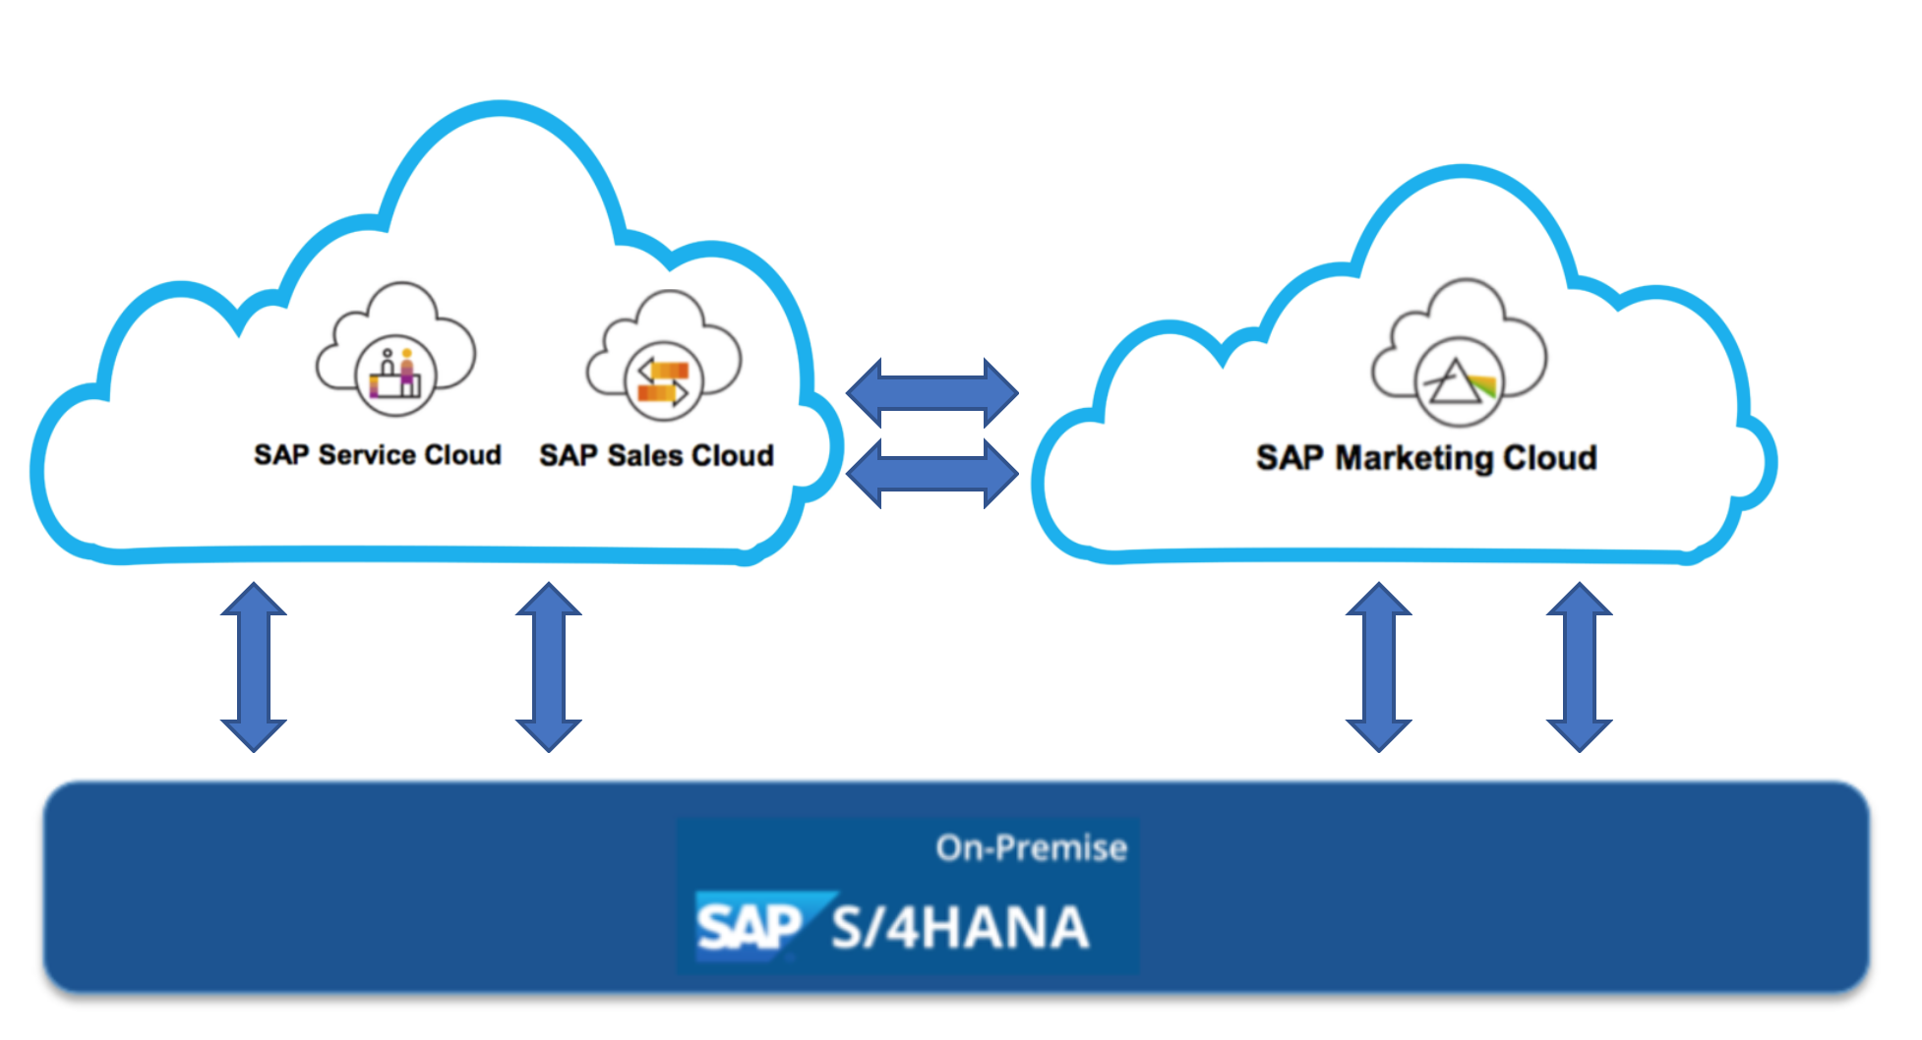
Figure 1: Overview of SAP system architecture for front office.
SAP C4C is a cloud-based solution that can be run on a web browser. C4C can be accessed on a desktop computer, tablet, or mobile device. As long as a user is within the SCE network, the user is able to access the C4C functionalities (including front office processes, which are detailed later in this document). A user is required to have valid login credentials and the required authorization in order to access the system.
C4C has two core functional areas that will both be enabled at SCE: SAP Service Cloud and SAP Sales Cloud. An overview of each module is described below:
- SAP Service Cloud: This module will be used primarily by the front office users. The key functional areas include: Activities Management, Tickets management, and Utilities Call Center
- SAP Sales Cloud: This module will be primarily used by BCD and CP&S groups. The key functional areas include: Sales Planning, Leads Management, Opportunity Management, and Territory Management. This document will briefly discuss the sales functionality. For further information on the sales processes, please refer to CIM-CS-16 - Manage Leads, Opportunities & Territory
*Note: Both Sales Cloud and Service Cloud functionality are within the Cloud for Customer system. A user’s business role assignment will determine the functionality they are able to access.

2.1.2.1 UI and General Navigation
In this section, the C4C UI components and navigation information will be discussed. The main UI elements are described below.

UI Navigation Component | Description
Navigation Bar | The navigation bar is the starting point to access the functionality in C4C. The navigation bar is made up of work centers, which contain a sub-menu called work center views. The navigation bar with work centers is denoted as #1.
Work Centers | Work areas are logically grouped within work centers. Upon selection of a work center, a submenu of functions will appear, called work center views. An example of this is demonstrated in Figure 2. The work center ‘Customer’ was selected, and upon selection, the submenu of work center views under ‘Customers’ is available for selection. The work center views available are ‘Accounts’, Contacts, and ‘Individual Customers’, which are the various types of customers. Work centers are denoted as #1.
Work Center View | Work center views are the sub-menu of functionality for each work center. Once a view is selected, the user can perform a specific function. This is outlined as #2.
Facet | The additional tabs that appear across the top of the screen when a user is within an account are called facets (Tabs). This is denoted as #3.

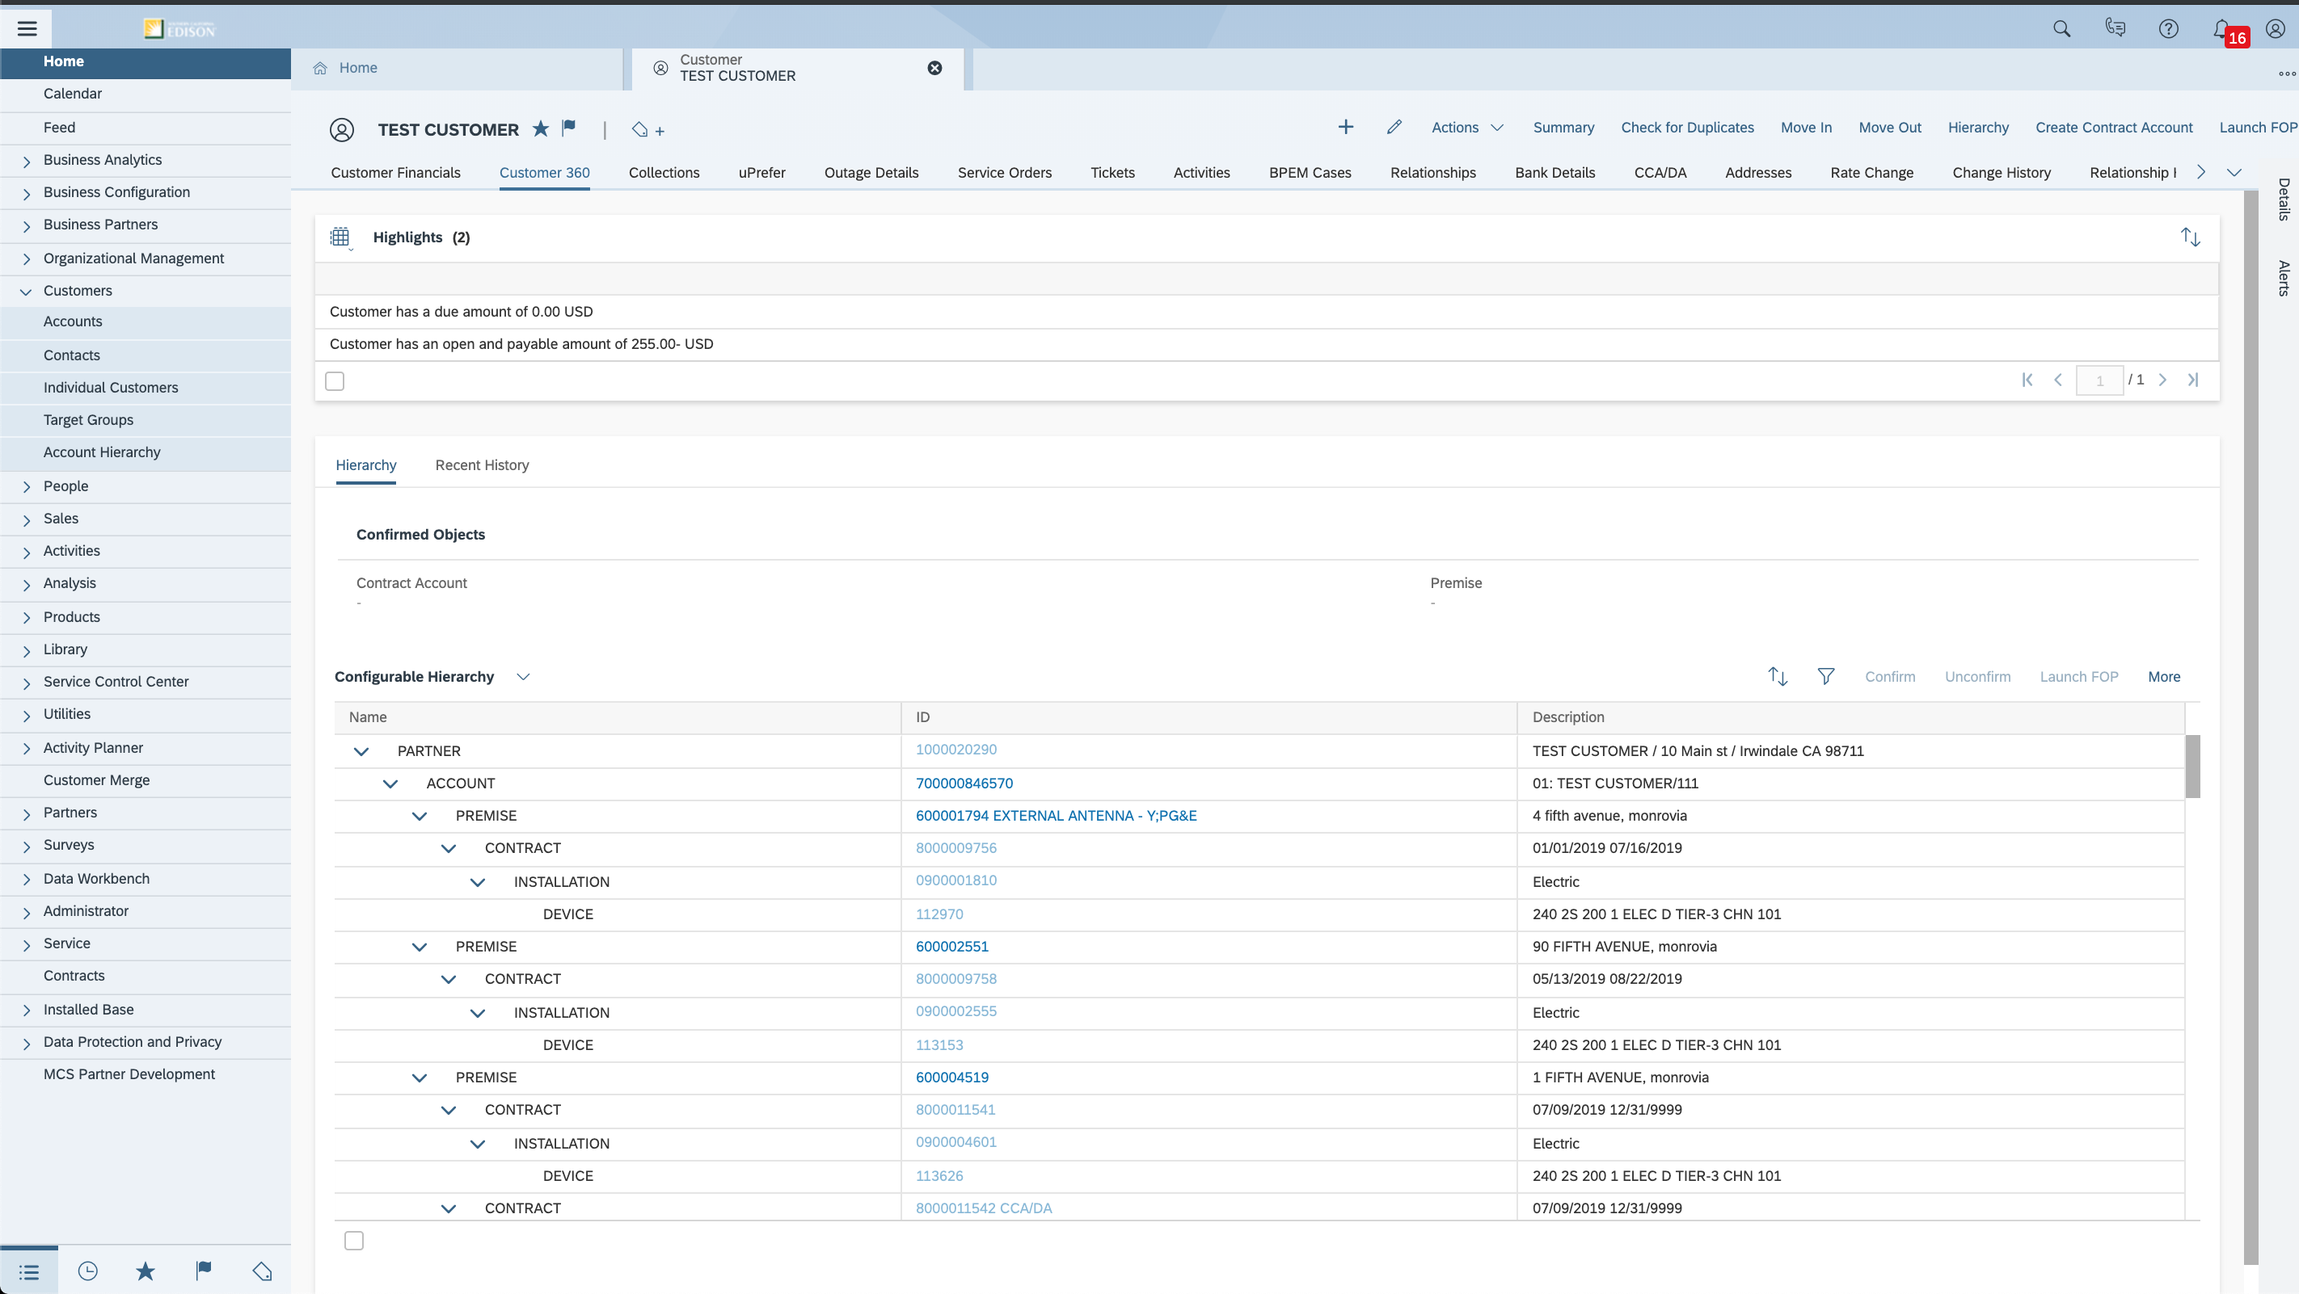
1
2
3
Figure 2: Customer 360 Facet using the Responsive UI

Navigation
There are two navigation bar options which will be configured for SCE, the Flat List and Hierarchy view.
Flat List Menu – This will be assigned to non-administrator, end-user roles, e.g. Call Center users. Since their user access restricted, the flat menu is optimal, as it has icons, is easy to read, and minimal clicks are required. Drill downs are not needed, since the access is already heavily restricted.
Hierarachy Menu – This will be assigned to administers and super users that have elevated access. This navigation menu groups the work centers into a hierarchy which is easier to navigate and reduces the amount of up-down scrolling required to find a workcenter. For example, the ‘Customers’ work center has been expanded in Figure 4A, and the

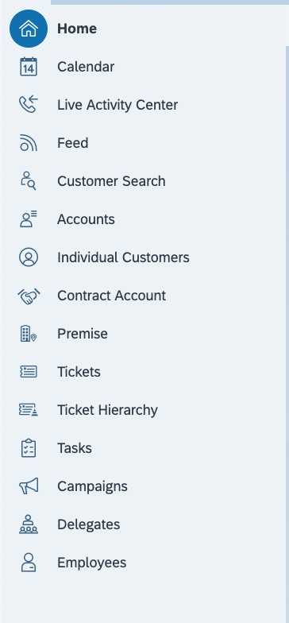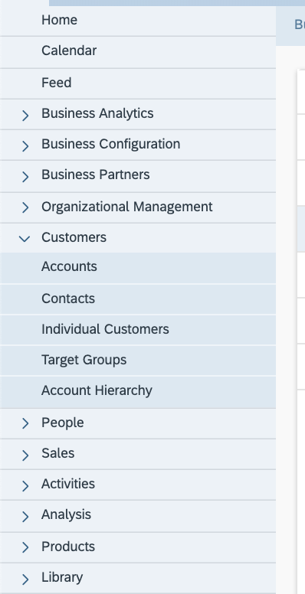
Figure 3: Flat Menu vs Hierarchy Menu

2.1.2.2 UI and General Navigation - Home Page
When a user logs into C4C, the landing page will be the Home page. The Home page provides an overview of items that require the user’s attention; KPI’s, reports, or dynamic Rich Site Summary (RSS) Feeds. Each tile (icon) provides an overview of the information, and serves as a link for navigation into additional details. The home page can be configured for each business role to show the most pertinent information. The BCD user roles may have tiles (icons) for leads, opportunities, and sales forecasting (as shown in Figure 4), while a front office manager may have tiles (icons) specific to outstanding tickets. In addition to business role configuration, users also have the option to personalize their home page by adding tiles (icons) and grouping them based on their preferences. The background image can also be personalized. The standard background image which will be used by SCE is SAP Belize, shown below.

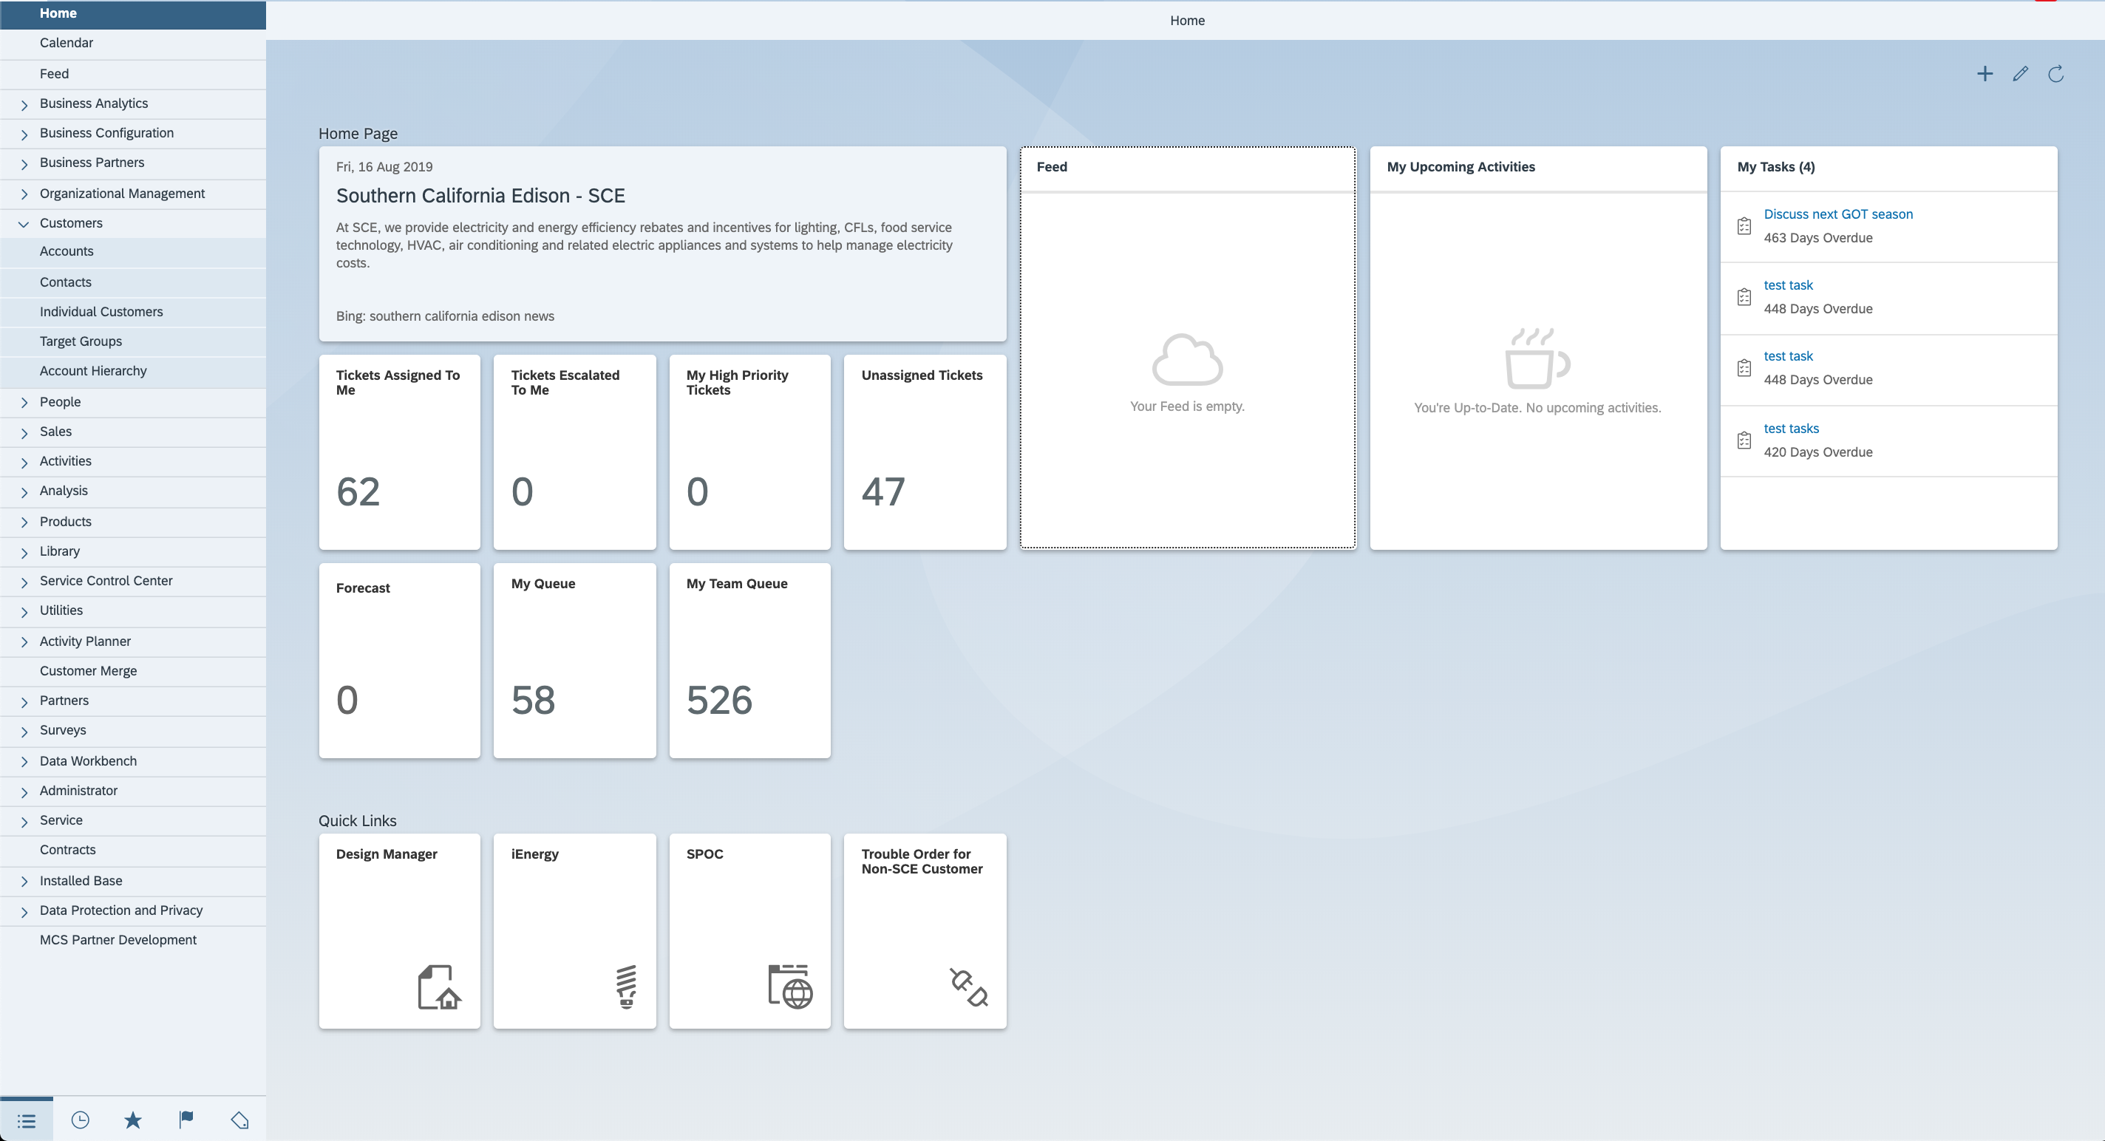
SCE Mash-Ups have been added in section ‘Quick Links’
Recent Feed Activity
Dynamic News tile using Bing RSS
Figure 4: Home Page, SAP Belize Background, Tiles

2.1.2.3 UI and General Navigation - Feed
The C4C feed provides users the ability to view updates on items that they are following (to be discussed in the next section). The feed mimics the functionality of common social media platforms by displaying updates in a sequence that users can quickly review throughout the day as shown in Figure 5. Users have the ability to post updates within their feed and tag other employees, or C4C objects within the post. Users have the ability to filter and personalize their feed sources so that only certain events are displayed on their feed. In addition, users can personalize their feed so that they can receive an automated system emails for specific updates (Leads, Opportunities, etc.), as shown in Figure 6, which provides them a list of the activity from their feed.
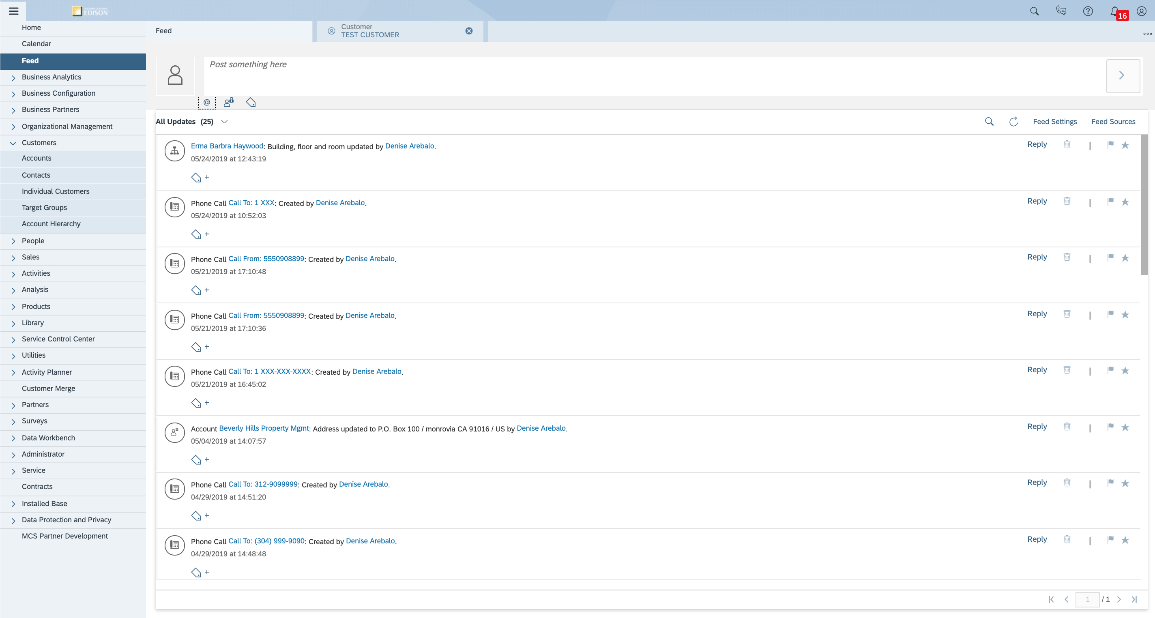
Figure 5: Sample Feed
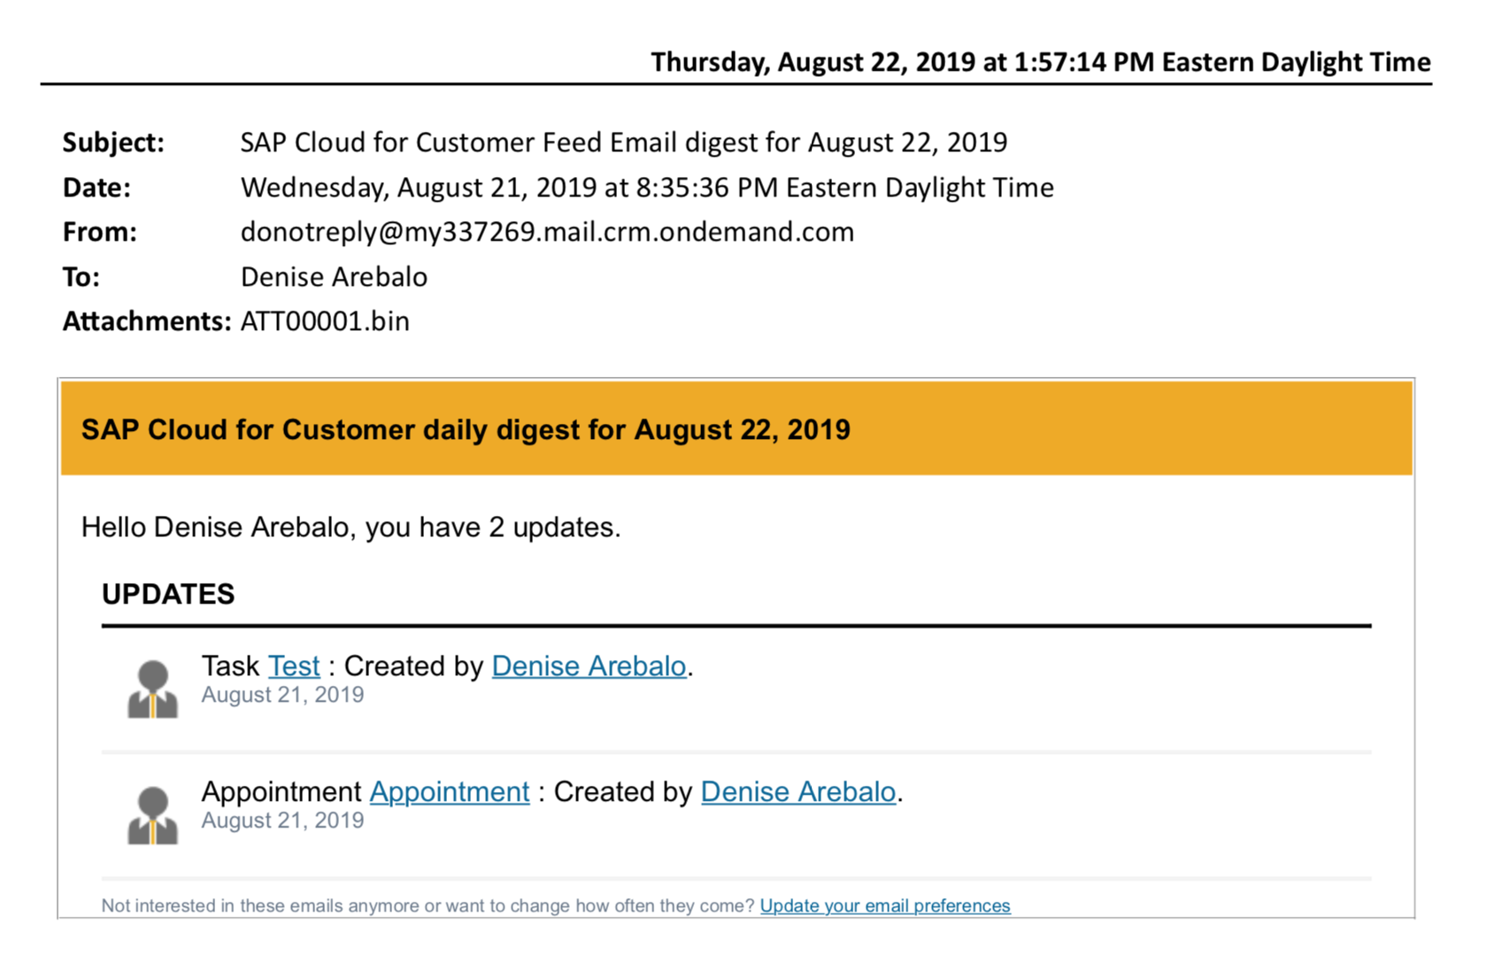
Figure 6: Sample Feed Digest Email

2.1.2.4 UI and General Navigation - Follow, Favorites, Flag, Hashtag and Posting an Update
C4C provides users the functionality to group and monitor specific accounts, customers, or C4C objects for updates by providing multiple options, described below.
Function | Description | C4C Icon
Follow | Users have the ability to follow accounts or C4C objects (ex: C4C ticket, activity, lead, or account). This functionality can be used by users to follow assigned accounts, or a call center manager to follow a ticket until it has been resolved. | 
Favorites | Designating an account or C4C object as a ‘Favorite’ and by ‘Flagging’ it, has the same result; it adds the object to the user’s personal pane so that it can be quickly accessed. Therefore, users can leverage both functionality, but differentiate their list by type of object. For example, designate only customers or accounts as favorites, and use the Flag to follow tickets, activities, or sales leads. Users can view their favorites by accessing the pane on the bottom left, as shown in Figure 7. | 
Flag | Designating an account or C4C object as a ‘Favorite’ and by ‘Flagging’ it, has the same result; it adds the object to the user’s personal pane so that it can be quickly accessed. Therefore, users can leverage both functionality, but differentiate their list by type of object. For example, designate only customers or accounts as favorites, and use the Flag to follow tickets, activities, or sales leads. Users can view their flagged items by accessing the pane on the bottom left, as shown in Figure 7. | 
Hashtag | Users are able to add tags to accounts, customers, or C4C objects. This allows users to group multiple activities together for the ability to easily search when needed. Users can search for the hashtags by accessing the pane on the bottom left as shown in Figure 7. | 
Post an Update | Users can post updates from within a C4C object that will appear within the feed. Users can tag other employees or another object within the update. (See Figure 8) | 
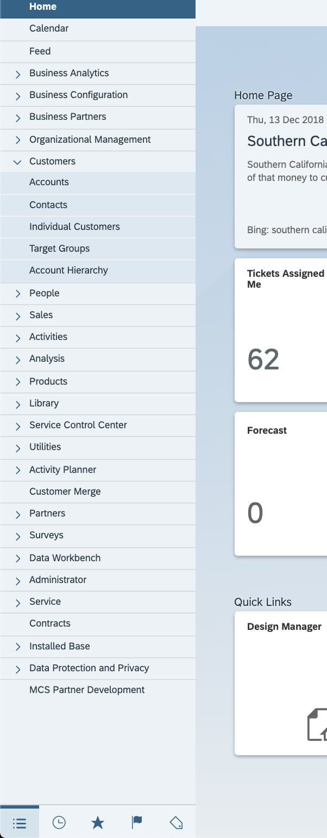

Figure 7: Use the Panes to switch between favorites, flagged items, and hashtags

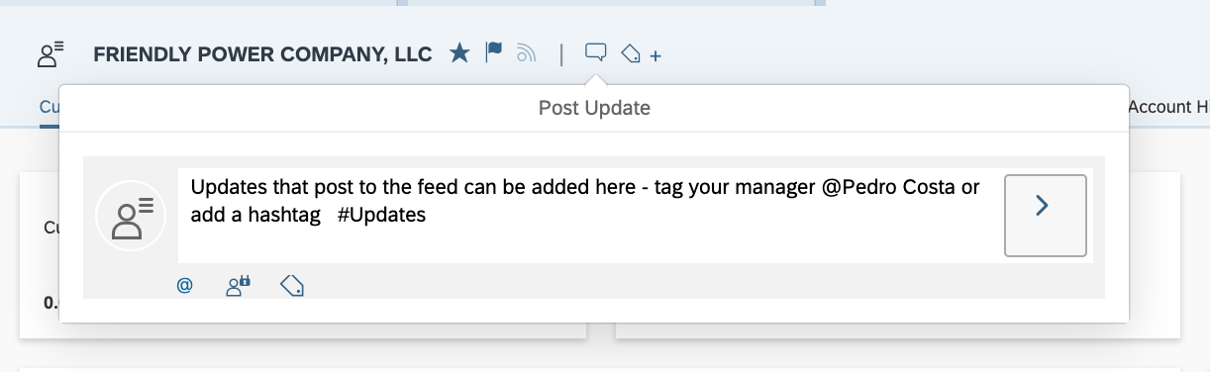
Figure 8: Posting an Update from within an Account

2.1.2.5 UI and General Navigation - Notifications
C4C delivers a standard notifications area that alerts users when they have a C4C object that gets routed to them (assigned), or becomes past due, as shown in Figure 9. These notifications can be configured using the ‘Workflow Rules’ facet. Notifications can be configured to be generated based on different events within C4C, but can only be generated for C4C objects.
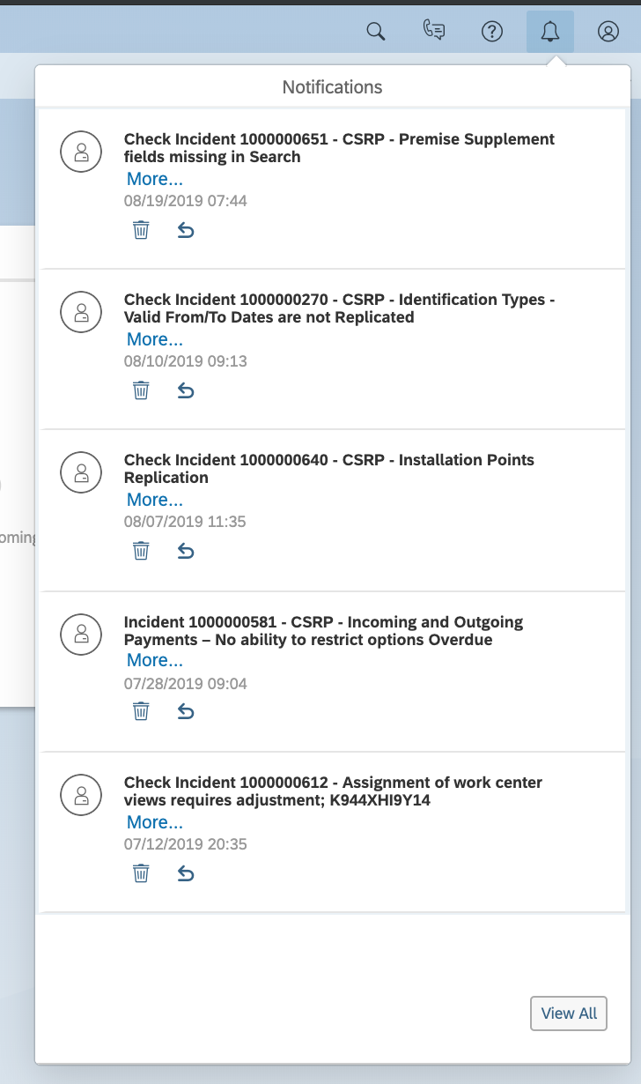
Figure 9: User Notifications

2.1.2.6 UI and General Navigation - Personalization
In addition to the home page personalization, (discussed in Section 2.1.2.2) end users will have the ability to modify the layout of by hiding/displaying fields that are available, and rearranging their facets (Tabs) as shown in Figure 10.
Note: User personalization is only allowed for data the user is authorized to view. If a facet (Tab) is hidden from a user due to authorization controls, they will not be able to expose the facet (tab) using personalization.
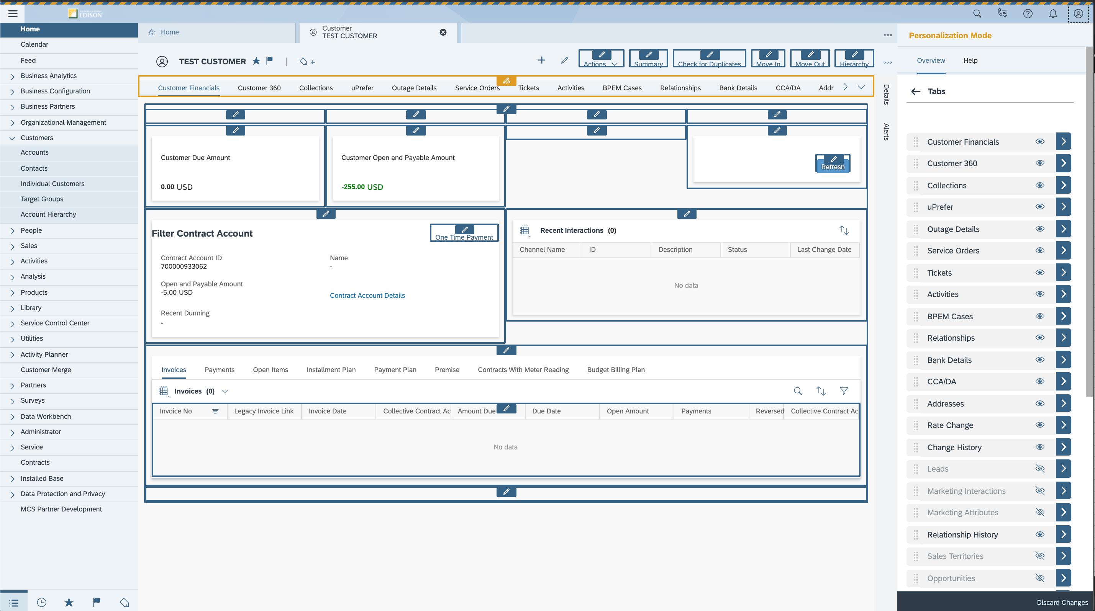
Figure 10: Personalization within the RUI

2.1.3 Service Cloud
The Service Cloud module will be used for Activity Management, Tickets Management (CIM-CS-08 - Complaints, Claims, and Survey), and Utilities Call Center (CIM-CS-13 - Manage Inbound Telephone Call - IVR). This document will only provide an overview of this functionality, detailed functionality is covered in multiple BPD’s which are referenced.

2.1.3.1 Service Cloud - Activity Management
Activities will be used by SCE to record customer interactions. The type of activities created depends on the type of interactions, which are shown in Figure 11. A customer’s activities can be viewed through the Activities facet (Tab). For additional information on this process, refer to CIM-CS-12 - Manage Customer Interactions.

- Phone Calls: Activity will be created to record after call wrap up and/or input notes once a call with the customer has been completed.
- Appointments: An appointment is a planned meeting with a customer. Appointments are created prior to a meeting with the customer, and are visible within the C4C calendar. This will be used by the BCD group for their assigned/unassigned customers. For additional information on activities, please refer to CIM-CS-16 Manage Leads, Opportunities, and Territory

- Tasks: A task can be created for oneself, or for another user with the intent of tracking the activity to completion. An example would be if a customer request additional information or action item is noted during an in-person visit, creation of the tasks allows for the action to be tracked to completion. SCE has decided not to leverage Tasks functionality. 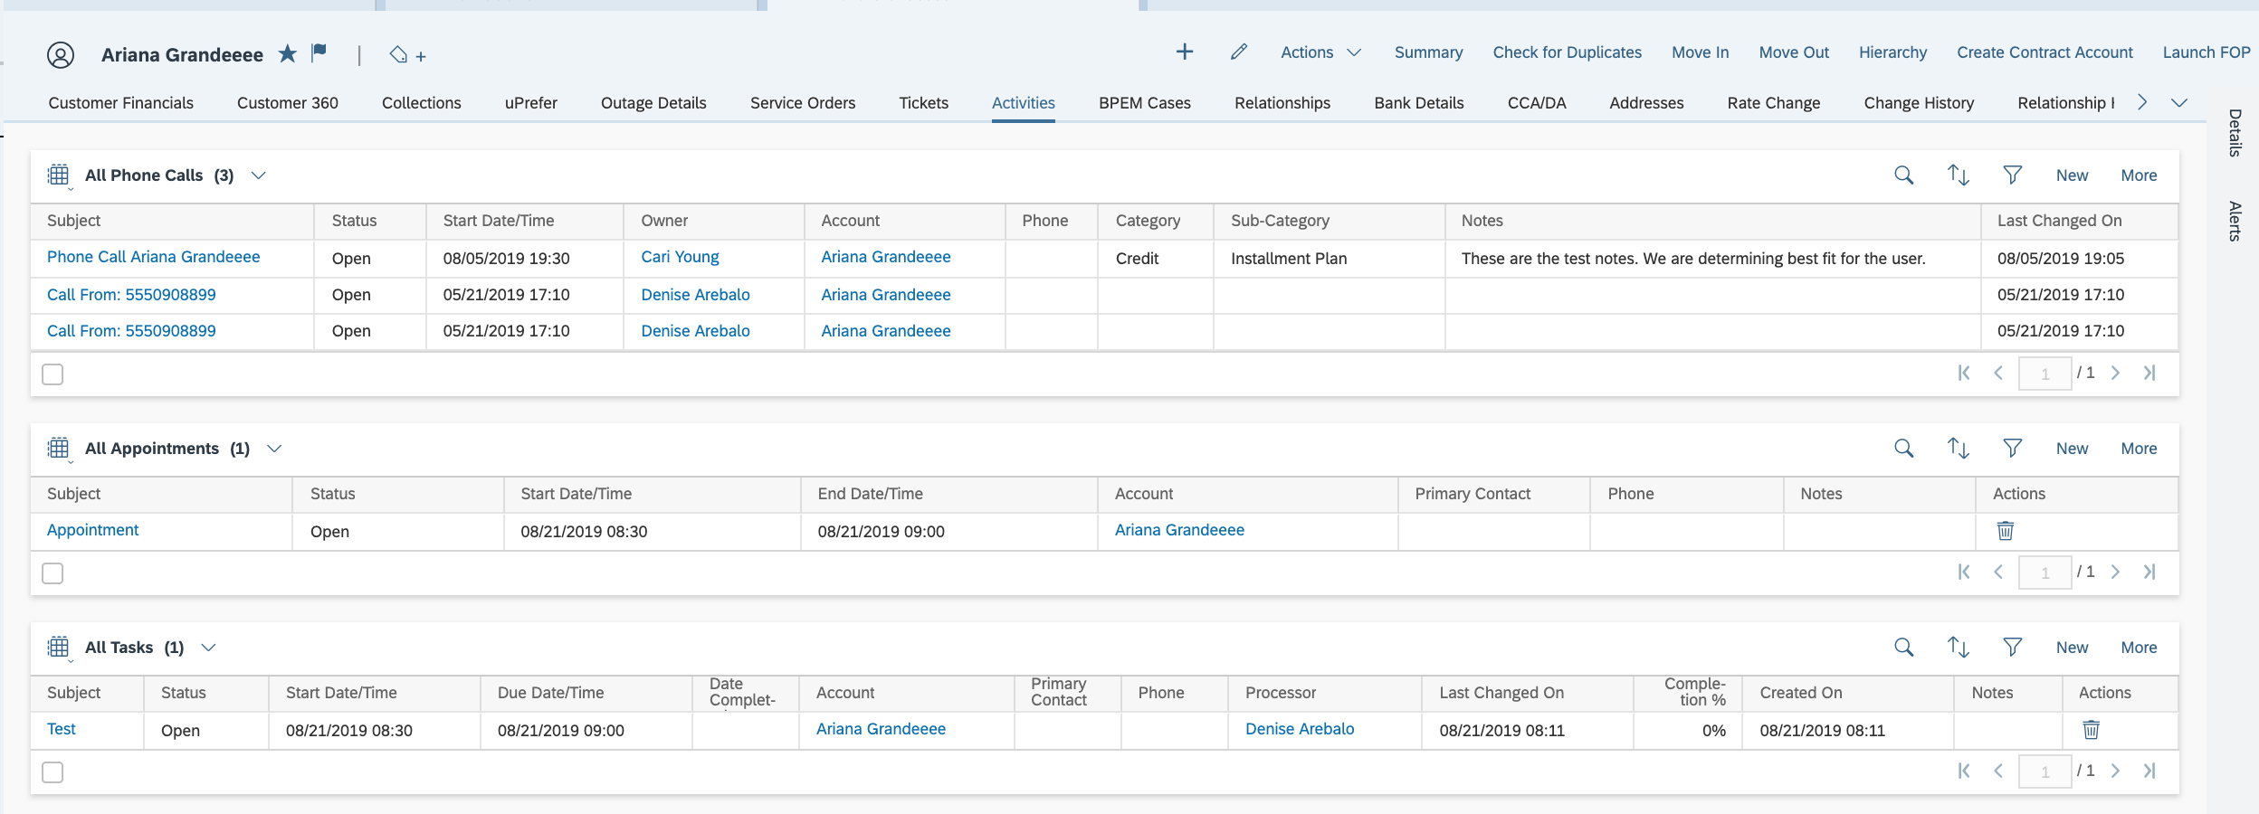
Figure 11: Activities Facet (Tab)

2.1.3.2 Service Cloud – Ticket Management
Tickets are used within C4C to record and track work that needs to be performed. At SCE, tickets will be used to track work among agents. If routing to the back-office is required, the users will create a BPEM case using an FOP. For additional information on this process, please refer to CIM-CS-06 - Handle Customer Inquiries and CIM-CS-07 - Handle Bill Inquiries

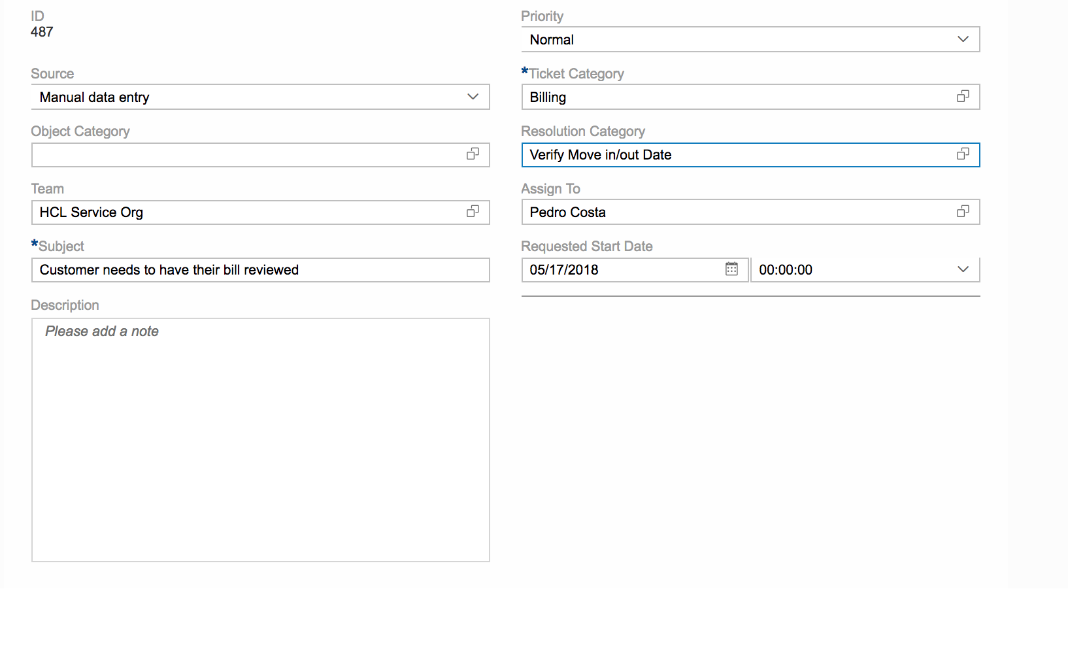
Figure 12: Create Service ticket

2.1.4 Utilities Call Center
The functionality within the Utilities Call Center includes four utilities specific facets (tabs), which are detailed in this section.

2.1.4.1 Utilities Call Center- Utilities Financials
The Utilities Financials facet (tab) will be the landing page when a customer’s account is accessed by the users. The standard facet has been renamed at SCE to “Customer Financials”. This facet (tab) shows a detailed overview of the SCE business partner; invoices, payments, open items, installment plans, and payment plans, in addition to the premise and contracts associated with the business partner, as shown in Figure 14. Users can update meter readings, view invoices, or enroll the customer in a budget billing plan or installment plan.
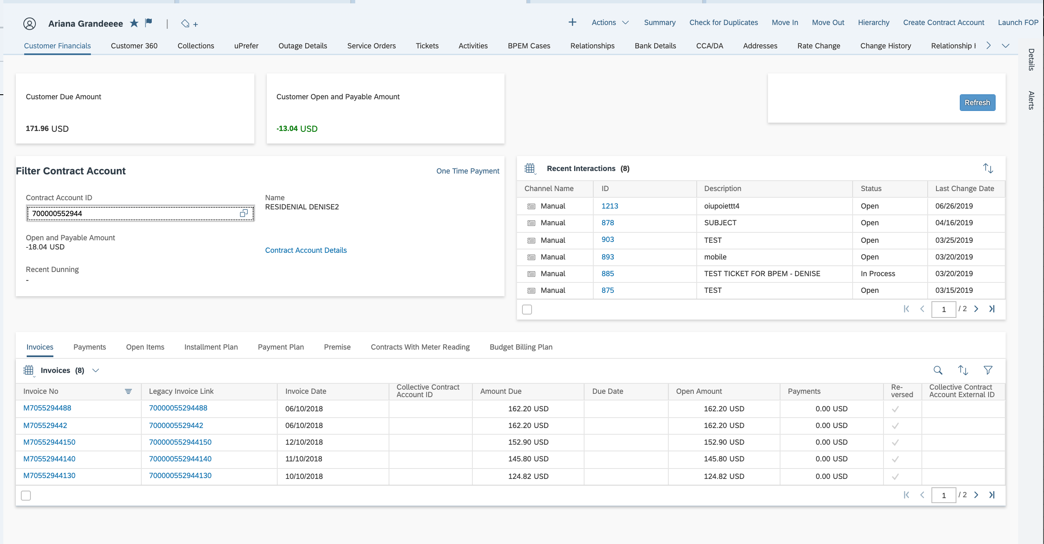
Figure 14: Utilities Financials, renamed ‘Customer Financials’
The Utilities Financials provides an overview of the recent financial activity on the account. The user also has the ability to take a One Time Payment

The Utilities Financials facet (tab) has the following sections that are displayed:
- Invoices: This section will contain the list of invoices. The invoice numbers are hyperlinks which launch the PDF of the individual invoices. This section will contain both legacy invoices and SAP generated invoices. Enhancement 2350 Legacy Invoices in C4C has been implemented so that Legacy invoices are available to be viewed from this section.
- Payments: A list of the customer’s recent payments including the posting date and cleared amount are displayed (see Figure 16).
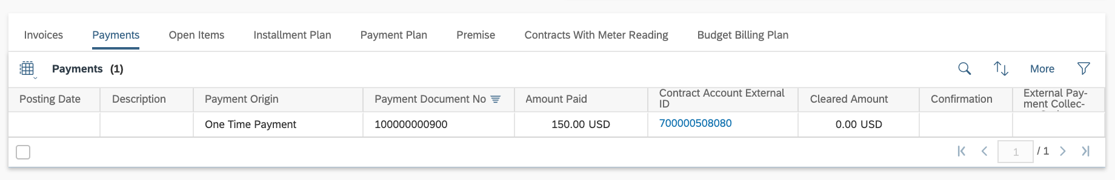
Figure 16: Payments
- Open Items: This section displays unpaid items that are grouped and displayed for each contract account. If needed, the user can set an individual item lock to prevent dunning or clearing.
- Installment Plans: Installment Plans can be issued to a customer via SCE.com, IVR or by calling and requesting through an authorized Front Office or Back Office agent. Installment plans can be displayed, modified and deactivated from within C4C, as shown in Figure 15. When an inbound call is received to request a payment arrangement, the front office agent will review the business partner’s overall credit profile to validate that the customer qualifies for an installment plan based on SCE’s business rules and credit policy. If the customer is deemed eligible for payment arrangements, the front office agent can select the appropriate Installment plan based on SCE Business Rules. Please reference BPD-CC-FI-08 - Manage Collections (Dunning) - Manage Payment Arrangements Status for additional information.
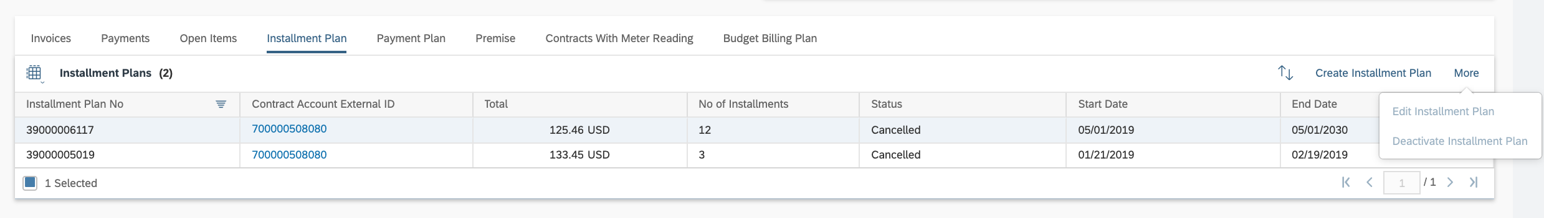
Figure 15: Installment Plan

- Premises: Displays the list of premises where the customer has an active contract.
- Contracts with Meter Reading: This section displays all contracts for the customer with their monthly meter readings for Mechanical Meters. The user can select a row to display all recorded meter readings for the selected contract account. This will only display meter readings for non-AMI meters.
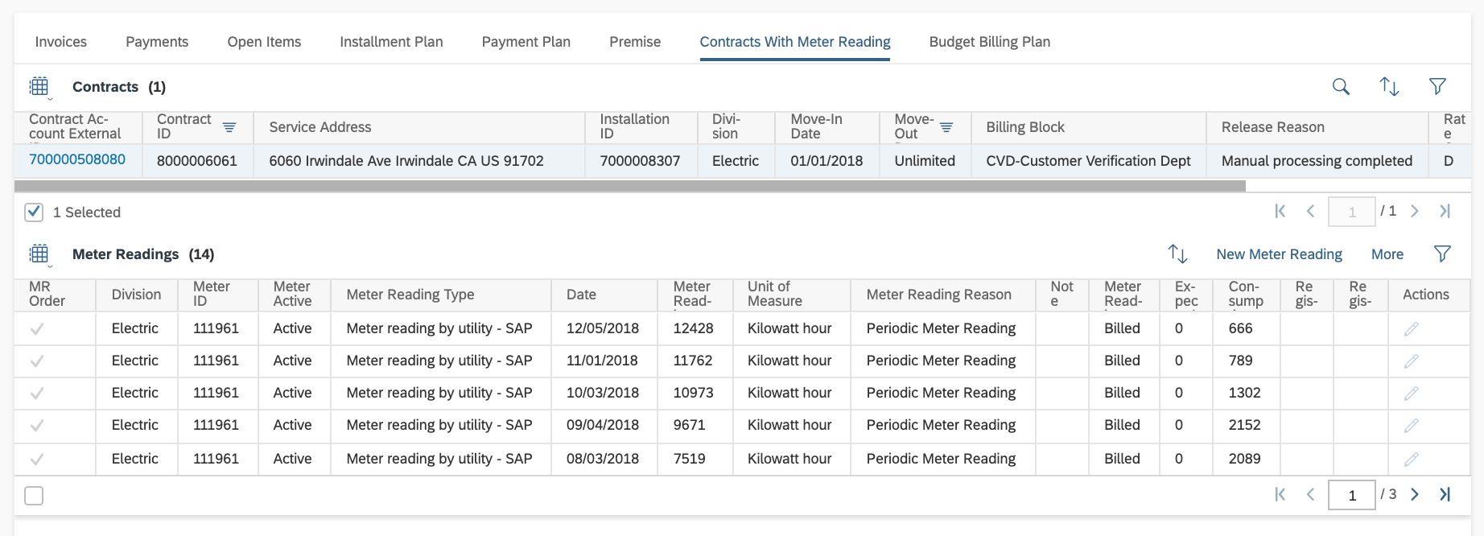
Figure 18: Contracts with Meter Reading

- Payment Plan: A Payment Plan is a budget billing plan (also known as level pay plan) that offers eligible customers the opportunity to pay for their annual service across 11 equal monthly payments. The first month of the plan is called “Month 1”. “Month 12” is the month that the customer receives the settlement bill. Payment Plans are visible and can be created in C4C as shown in Figure 17. For additional information regarding Budget Billing, please refer to BPD UB-BI-11 - Manage Bill Arrangements.
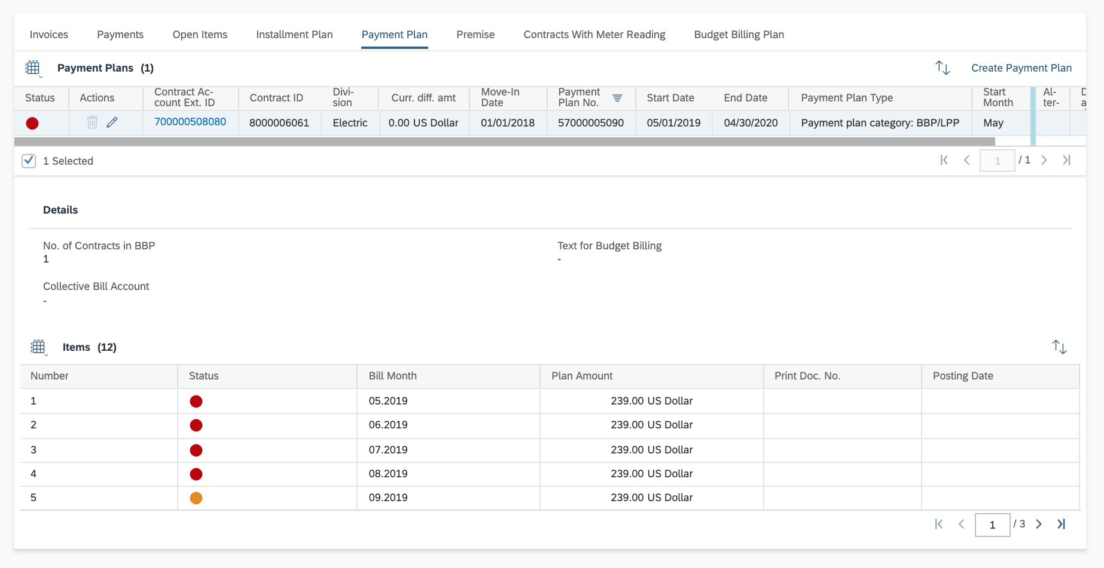
Figure 17: Payment Plans

2.1.4.2 Utilities Call Center- Utilities 360
The standard Utilities 360 facet (Tab) label has been changed for SCE to “Customer 360”.
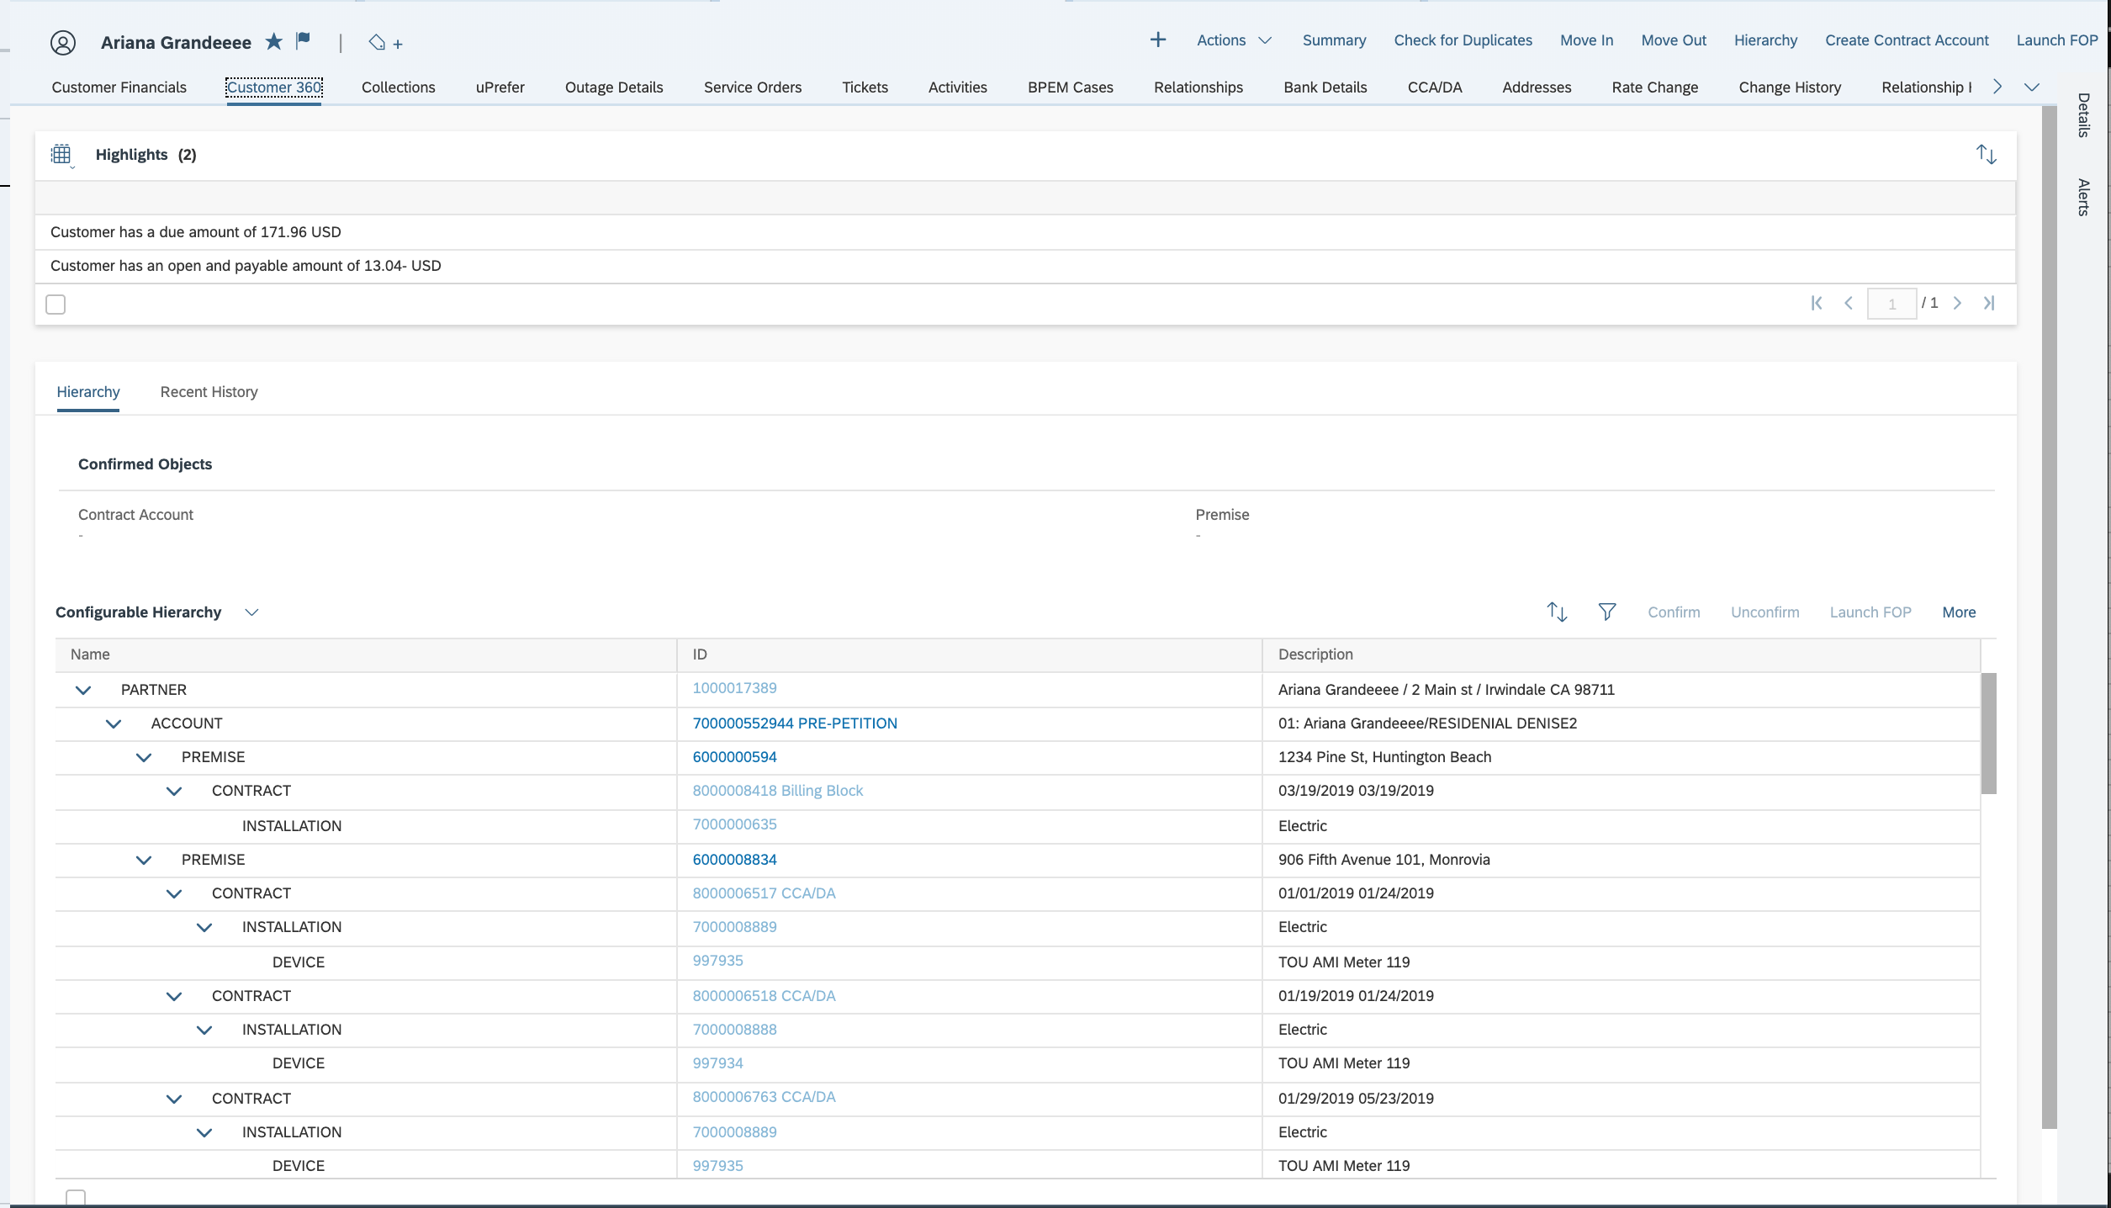
Configurable Hierarchy is the default view
Figure 19: Utilities 360

- Highlights - The highlights section is at the top, and by default, will display the customer’s total balance and overdue balance.
- Configurable Hierarchy - The Utilities 360 facet (Tab) provides the user with the object hierarchy including both business master data and a few of the key S4/HANA technical master data objects: the premise, installation, and device. The user can click on each row within the hierarchy to view additional information on the selected object directly below the hierarchy. In addition, the user will be able to view the parent/child relationships between collective accounts, as shown in Figure 20a. While the embedded hierarchy within the Utilities 360 is not configurable, an additional hierarchy is available, which will be configured for SCE to display specific attributes, such as fringe account,. The configurable hierarchy (as shown in Figure 20b can be accessed via the ‘Hierarchy’ button near the bottom right of the screen.
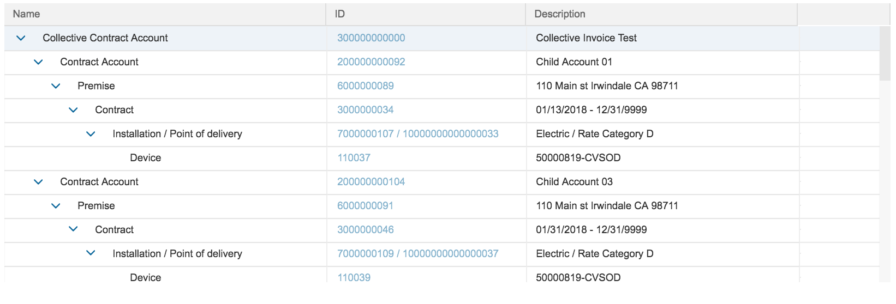
Figure 20a: Embedded Hierarchy with Collective Account

Recent History - This provides an overview of the most recent tickets, activities, invoices, payments, business partner contacts, and service orders created in one centralized view (see Figure 21).
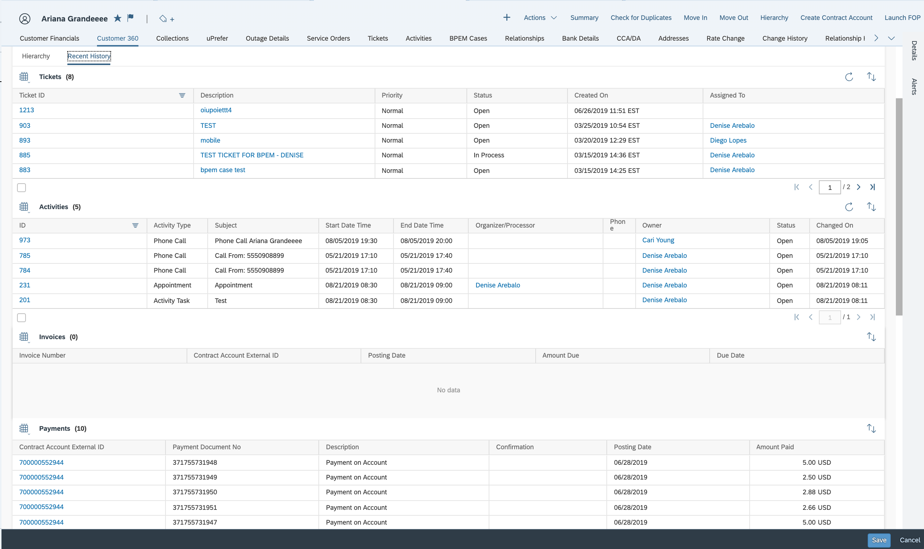
Figure 21: Recent History

2.1.4.3 Utilities Call Center- Utilities Service Orders
Front office agents will often need to create a field requests on behalf of a customer or respond to customer inquiries regarding the status of an outstanding field request. The Utilities Service Orders facet (Tab) in Figure 22, will be used to view the status of an order, to issue a new order, and to modify or cancel existing orders. This view shows only orders relevant to confirmed customer. To modify or cancel an order, select the order and click the ‘More’ button. To create service orders from C4C, the enhancement E-CIM-CS-17 Service Order Creation has been identified.
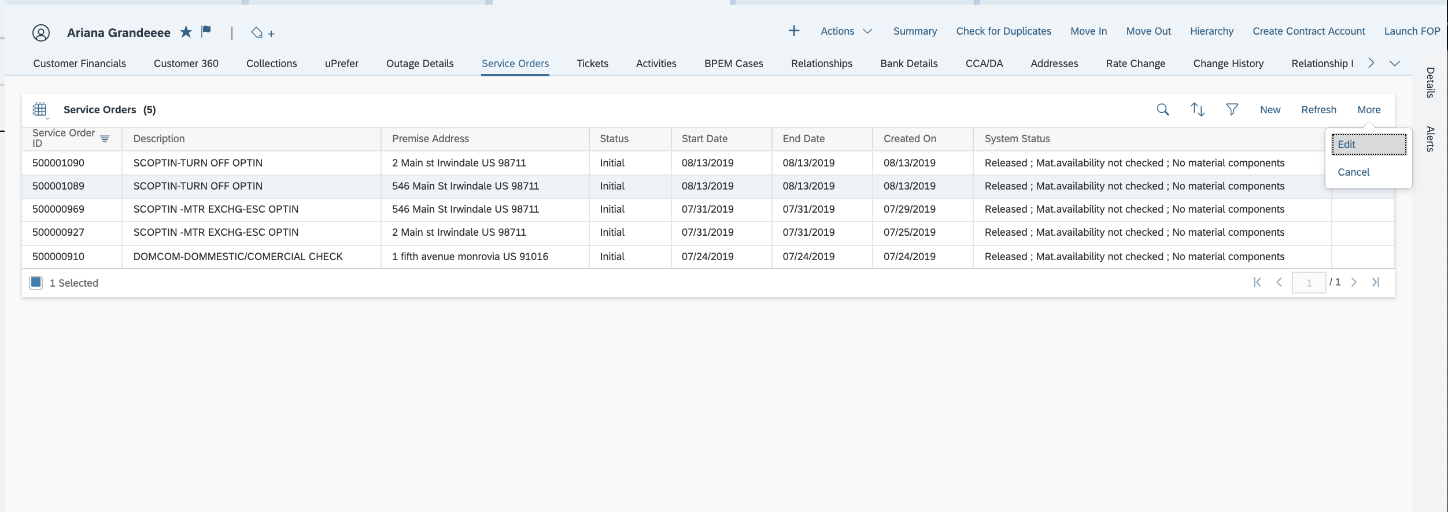
Figure 22: Service Orders Facet

If the ‘Edit’ option is selected, a pop-up will be generated to modify the request date (Figure 23). If the ‘Cancel’ option is selected, a pop-up to confirm the cancellation will be appear (Figure 24). For additional information on the service order process, please refer to BPD CIM-CS-04 Handle Trouble & Outage Contacts - Process Trouble Call and BPD CIM-CS-05-Handle Request-Process Field Work Request.
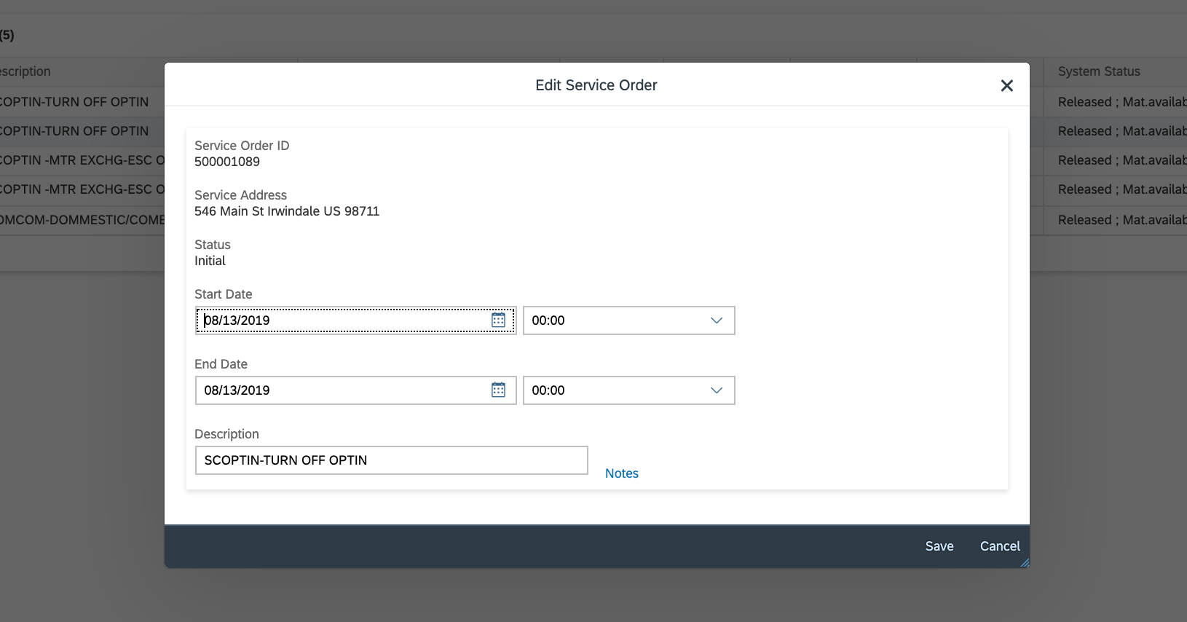
Figure 23: Edit Service Order
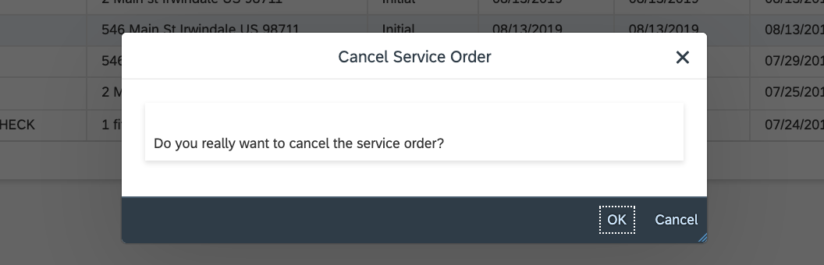
Figure 24: Cancel Service Order

In order to view planned, unplanned and macro outage events, an enhancement E-CIM-CS-17 C4C Outage View has been identified which will enhance the Utilities Service Orders facet (tab), as shown in Figure 25. A front office process has been identified which will allow users to query S4/HANA to view open service orders.

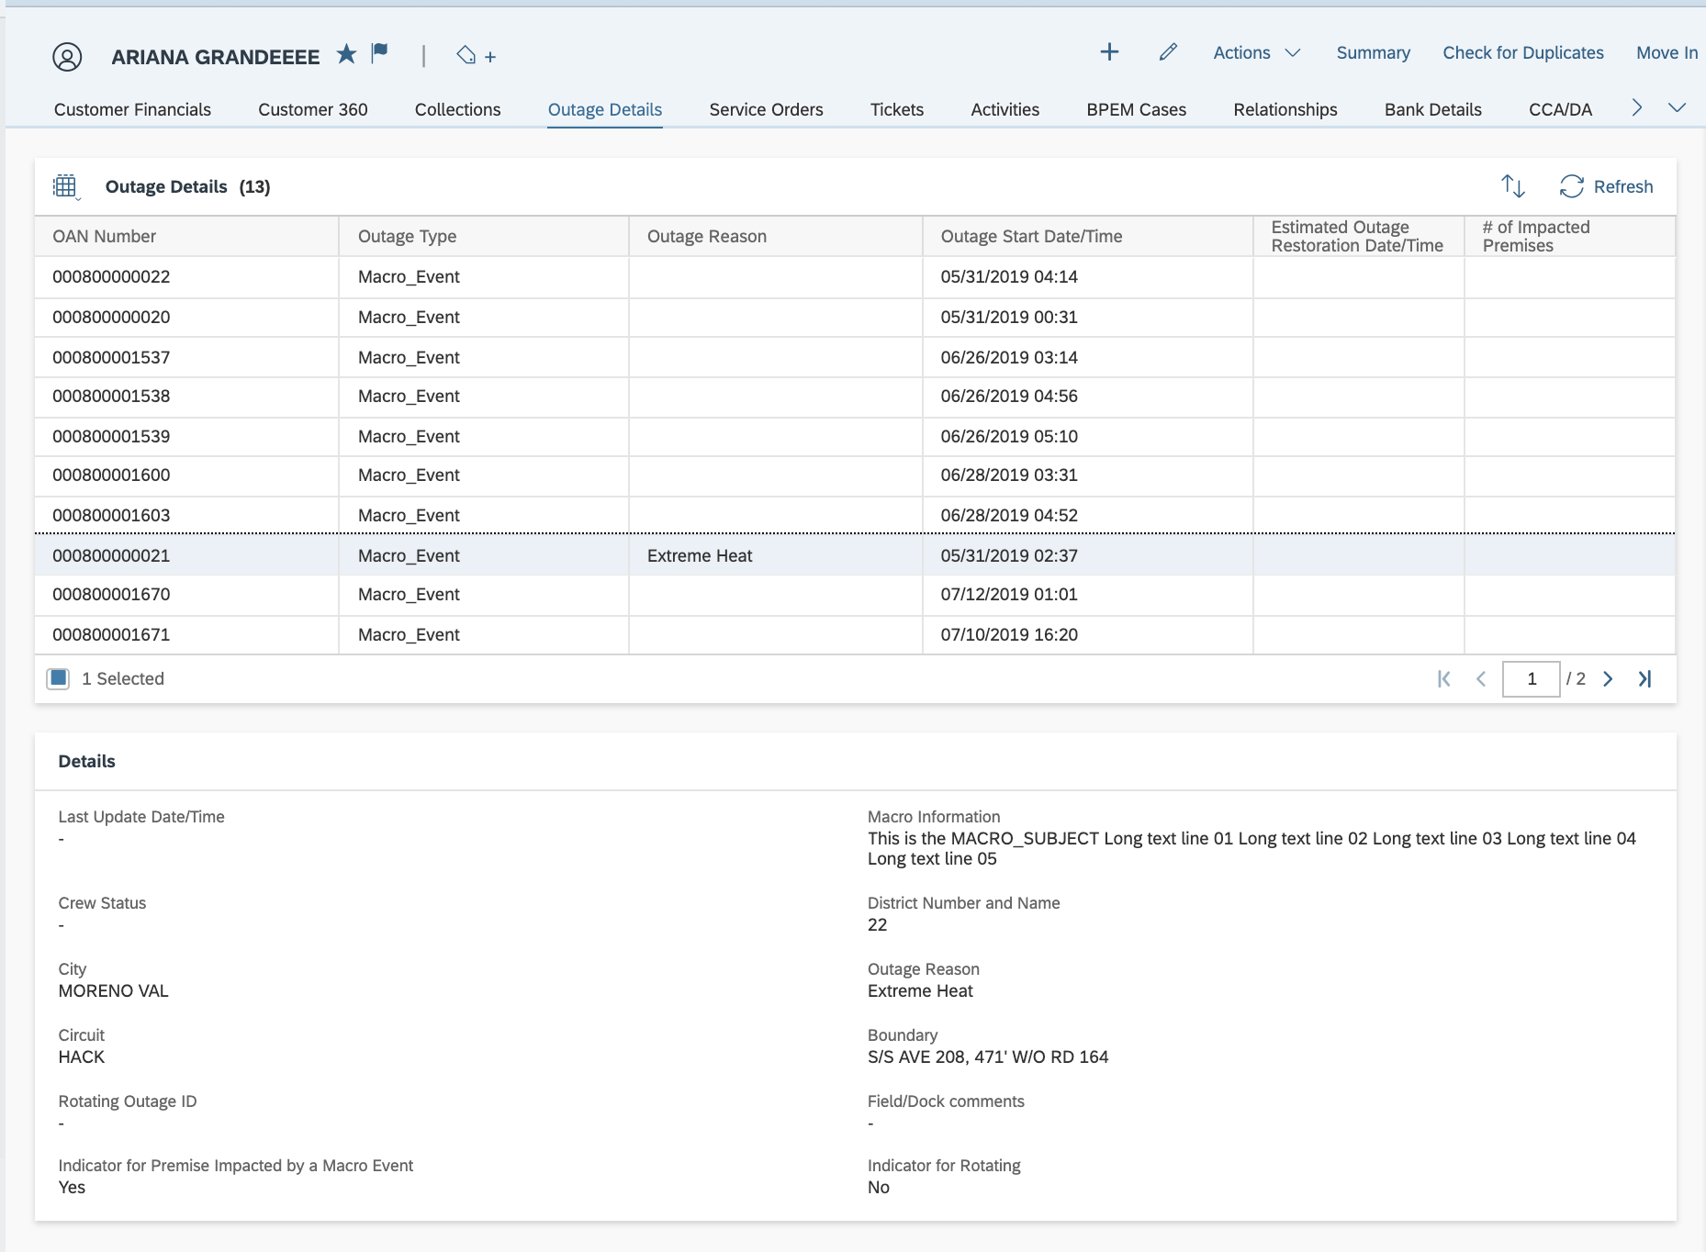
Figure 25: Macro Outage Event Enhancement

2.1.4.4 Utilities Call Center - Move-In / Move-Out

The move-in/out will be performed via C4C. The outline of each process is below. For additional details, please refer to Process - 15 - CIM-CS-02 - Handle Customer Move-in/Out - Contract New and Process - 16 - CIM-CS-03 - Handle Customer Move-in/Out - Contract End.

Move-In: Once a user has confirmed the customer, the user can perform the guided move-in procedure. The move-in will be initiated via the “Move-In” button. The move-in consists of 4 steps:
- Customer & Premise: This allows the user to select the desired premise and move-in date.
- Service: The user will select the relevant installations that the customer is selecting to have turned-on/energized.
- Contract Account & Billing: The user will have the ability to either select an existing contract account, or create a new contract account, and specify the billing address.
- Review: The user will review the selections with the customer, and then create the move-in.

Move-Out: Once the user has confirmed the customer, the user can perform the guided move-out procedure. The move-out will be initiated via the “Move-Out” button. The move-out consists of 4 steps:
- Customer & Premise: This allows the user to select the move-out premise and desired date.
- Service: The user will select the relevant services the customer is choosing to terminate.
- Contract Account & Billing: The user will have the ability to update their mailing address for the final bill.
- Review: The user will review the selections with the customer, and then create the move-out.

Credit Check
An external credit check to Experian is used to determine a customer’s risk class, which is based on their credit score. For information regarding the risk class to credit score mapping, please refer to BPD CC-FI-21 – Manage Credit – Credit Score. The risk class is then used to assess the amount of the deposit on move-in. For additional information regarding security deposit calculation, please refer to CC-FI-03 Manage Credit – Manage Security Deposit.
The credit check functionality will be available to front office agents through enhancement 1805 - E-CIM-CS-17 - Credit Check and I-CC-FI-03 Credit Check. In order to trigger the credit check, the BP must have the Social Security number populated (refer to BPD CIM-CS-01 Manage Business Partner).
While the credit check will be done outside of the C4C move-in guided process, the credit check are generally done as a part of a customer requested move-in, or ad-hoc when requested by the customer. Customers will generally request an ad-hoc credit check in cases where they do not want to pay the quoted security deposit amount, and would rather have the credit check done if they think their credit score will help waive the deposit amount.
Credit Check is not applicable for the following BP types:
  - New residential BP without SSN updated on BP record
  - Non-residential BP
  - Existing BP with a good credit worthiness score; consistent receipt of payment on time.
  - Sub-Metered Accounts
The initial credit check will result in one of the following:
Credit Check Result | Expected User Action
Credit Check completed | The SSN is found to be invalid. A BPEM case of “Customer Verification Investigation” is created manually to the Credit Team, The agent will proceed to create the move-in but will manually set the contract billing block, and cancel the service order (if applicable)
Refer to Credit | A BPEM case of “Customer Verification Investigation” is created manually to the Credit Team. The agent will proceed to create the move-in but will manually set the contract billing block and cancel the service order (if applicable).
Authentication Required | The customer is required to answer a series of questions to verify their identity.

Credit Bureau Authentication
The Experian Authentication process is only triggered if the results of the initial credit check are “Authenticatation Required”. There are two results of the Authenticate process are detailed below. The Experian Authentication process will be done through 1805 - E-CIM-CS-17 - Credit Check and an interface as defined in SCC 244 CIM-CS-17 Credit Bureau Authenticate.

Authentication Result | Expected User Action
Refer to Credit | The customer did not answer the authentication questions correctly. A BPEM case of “Customer Verification Investigation” is created manually to the Credit Team. The agent will proceed to create the move-in, but will manually add a billing block to the contract and cancel the reconnection service order (if applicable).
Authentication Successful | The customer answered the questions correctly. The user will assess/not assess deposit based on initial result (Authenticate with Deposit or Authenticate (without deposit).

2.1.4.5 Utilities Call Center - Rate Change
The Rate Change facet (tab) will be used when a customer request a rate change or when a user needs to display installation facts (billing parameters) on a customer’s contract (Figure 26).
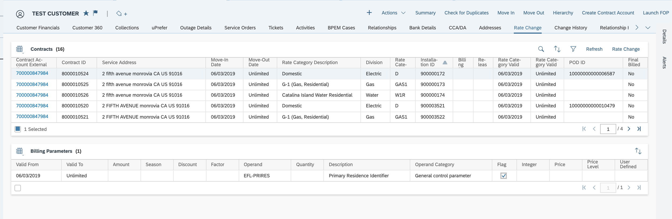
Figure 26: Utilities Rate Change Facet
If the user needs to change the customer’s rate, then they will select the contract and click ‘Rate Change’. A pop-up will be generated which will allow the user to select the new rate (Figure 27). When performing a rate change, the validity of the new rate will not be effective until the first day of their next billing period. A FRICEW object has been identified so that the next bill cycle date defaults for the user (E-CIM-CS-02 - Default next bill cycle date).
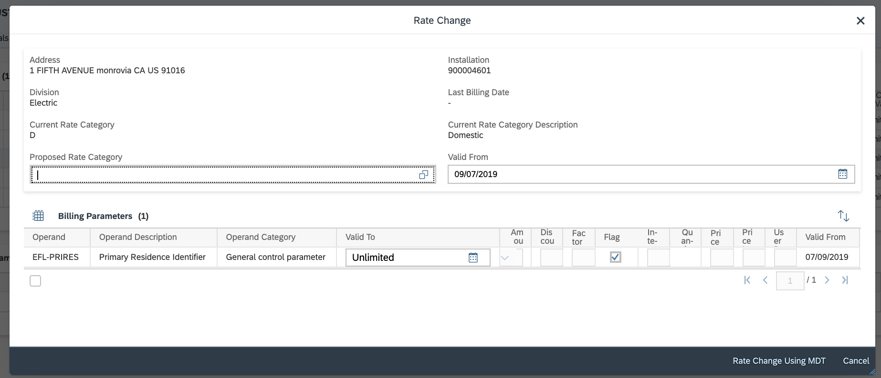
Figure 27: Rate Category Change
Using the field help available in the ‘Proposed Rate Category’ field (Figure 26), an additional pop-up will display the available rates. The enhancement E-CIM-CS-17 Rate Change Validations has been identified so that only certain rates are available for selection per the SCE business rules. Therefore, some rates which require back office processing or rates that are no longer open for enrollment (grandfathered rates) will be required to be performed via back-office only.
Once the user has selected the new desired rate, they will save the changes using the “Rate Change Using MDT” button.
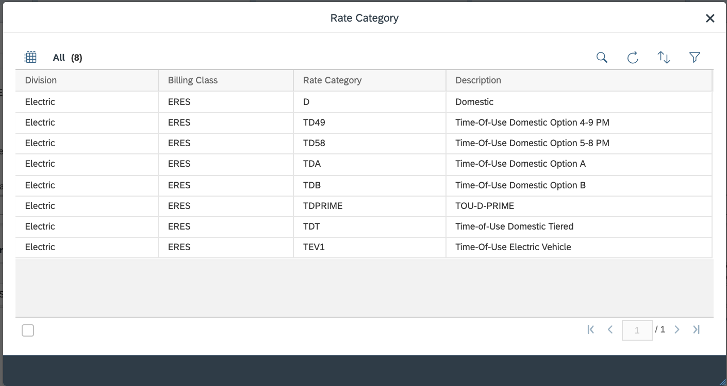
Figure 26: ‘Proposed Rate Category’ Selection Help

2.1.4.6 Utilities Call Center – Premise
The Premise facet provides users the ability to view details specific to a service location including:
- Overview of the service location address: This will inform the user of the premise type, detailed address, and
- Highlights: This section will inform the user if the location is connected / disconnected
- Customer Overview: This section details the customer that is active at the service location.
In addition, the user can view the service orders that were specifically created for the premise location.

The premise facet can be launched from within a customer’s account (to view the premise details), or a premise can be searched for independently. The move-in process can be initiated from this facet (tab), for additional information please refer to BPD CIM-CS-02 Handle Customer Move-in Out - Contract New.

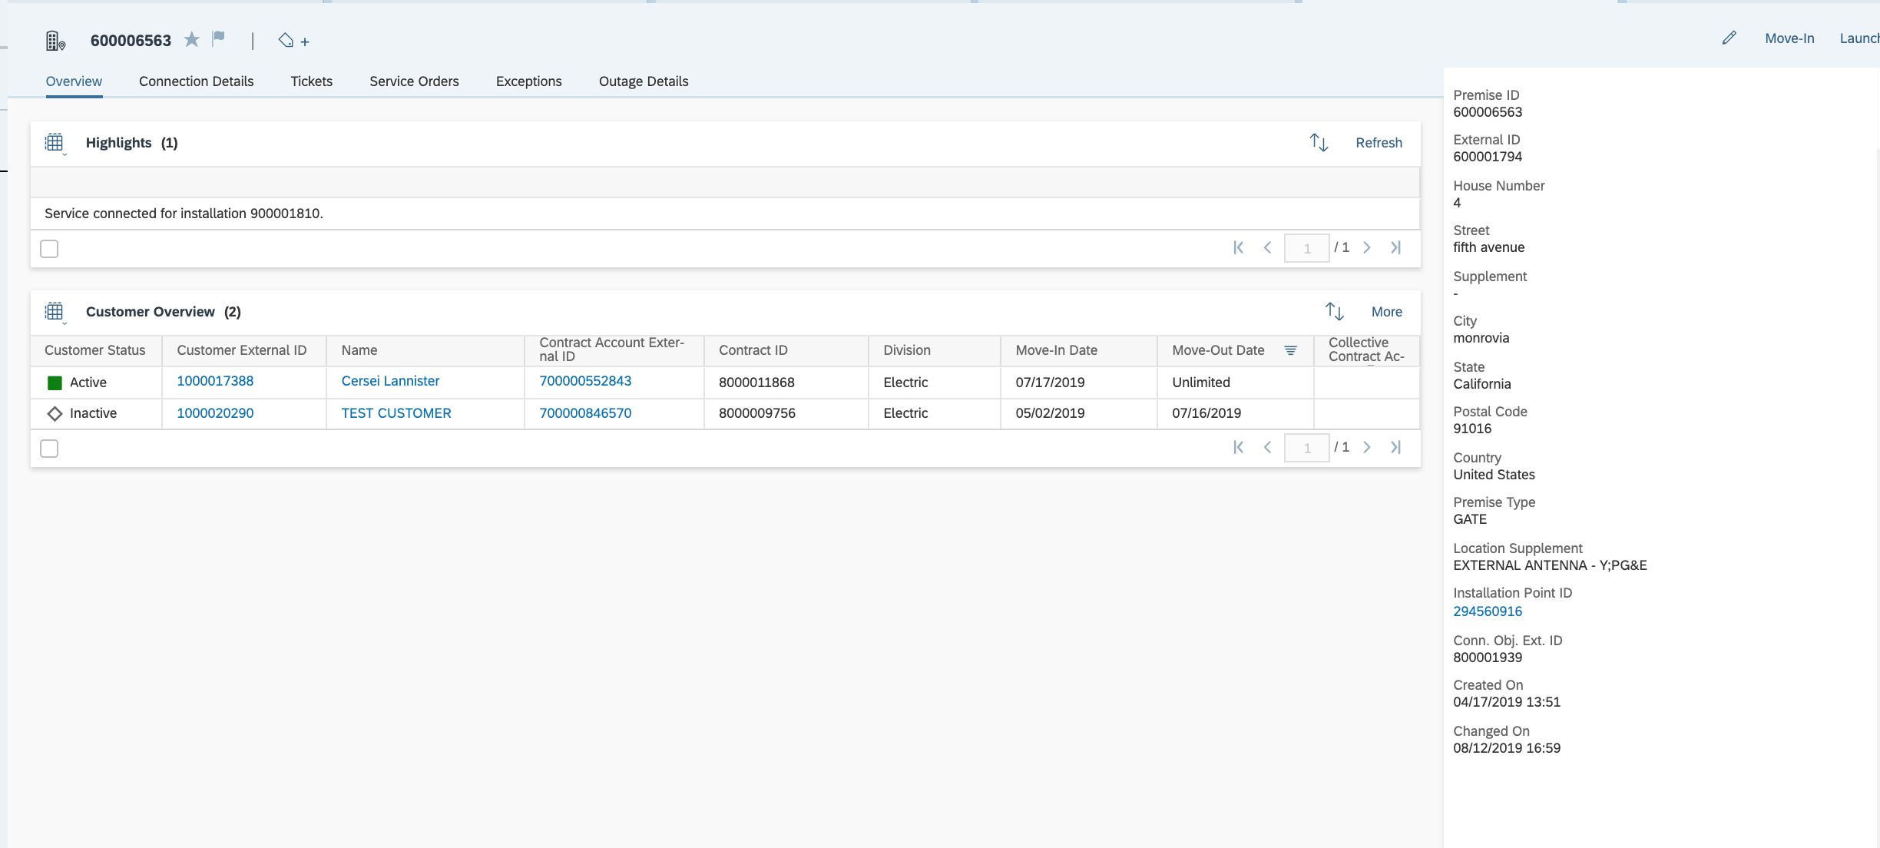
Figure 27: Premise Overview

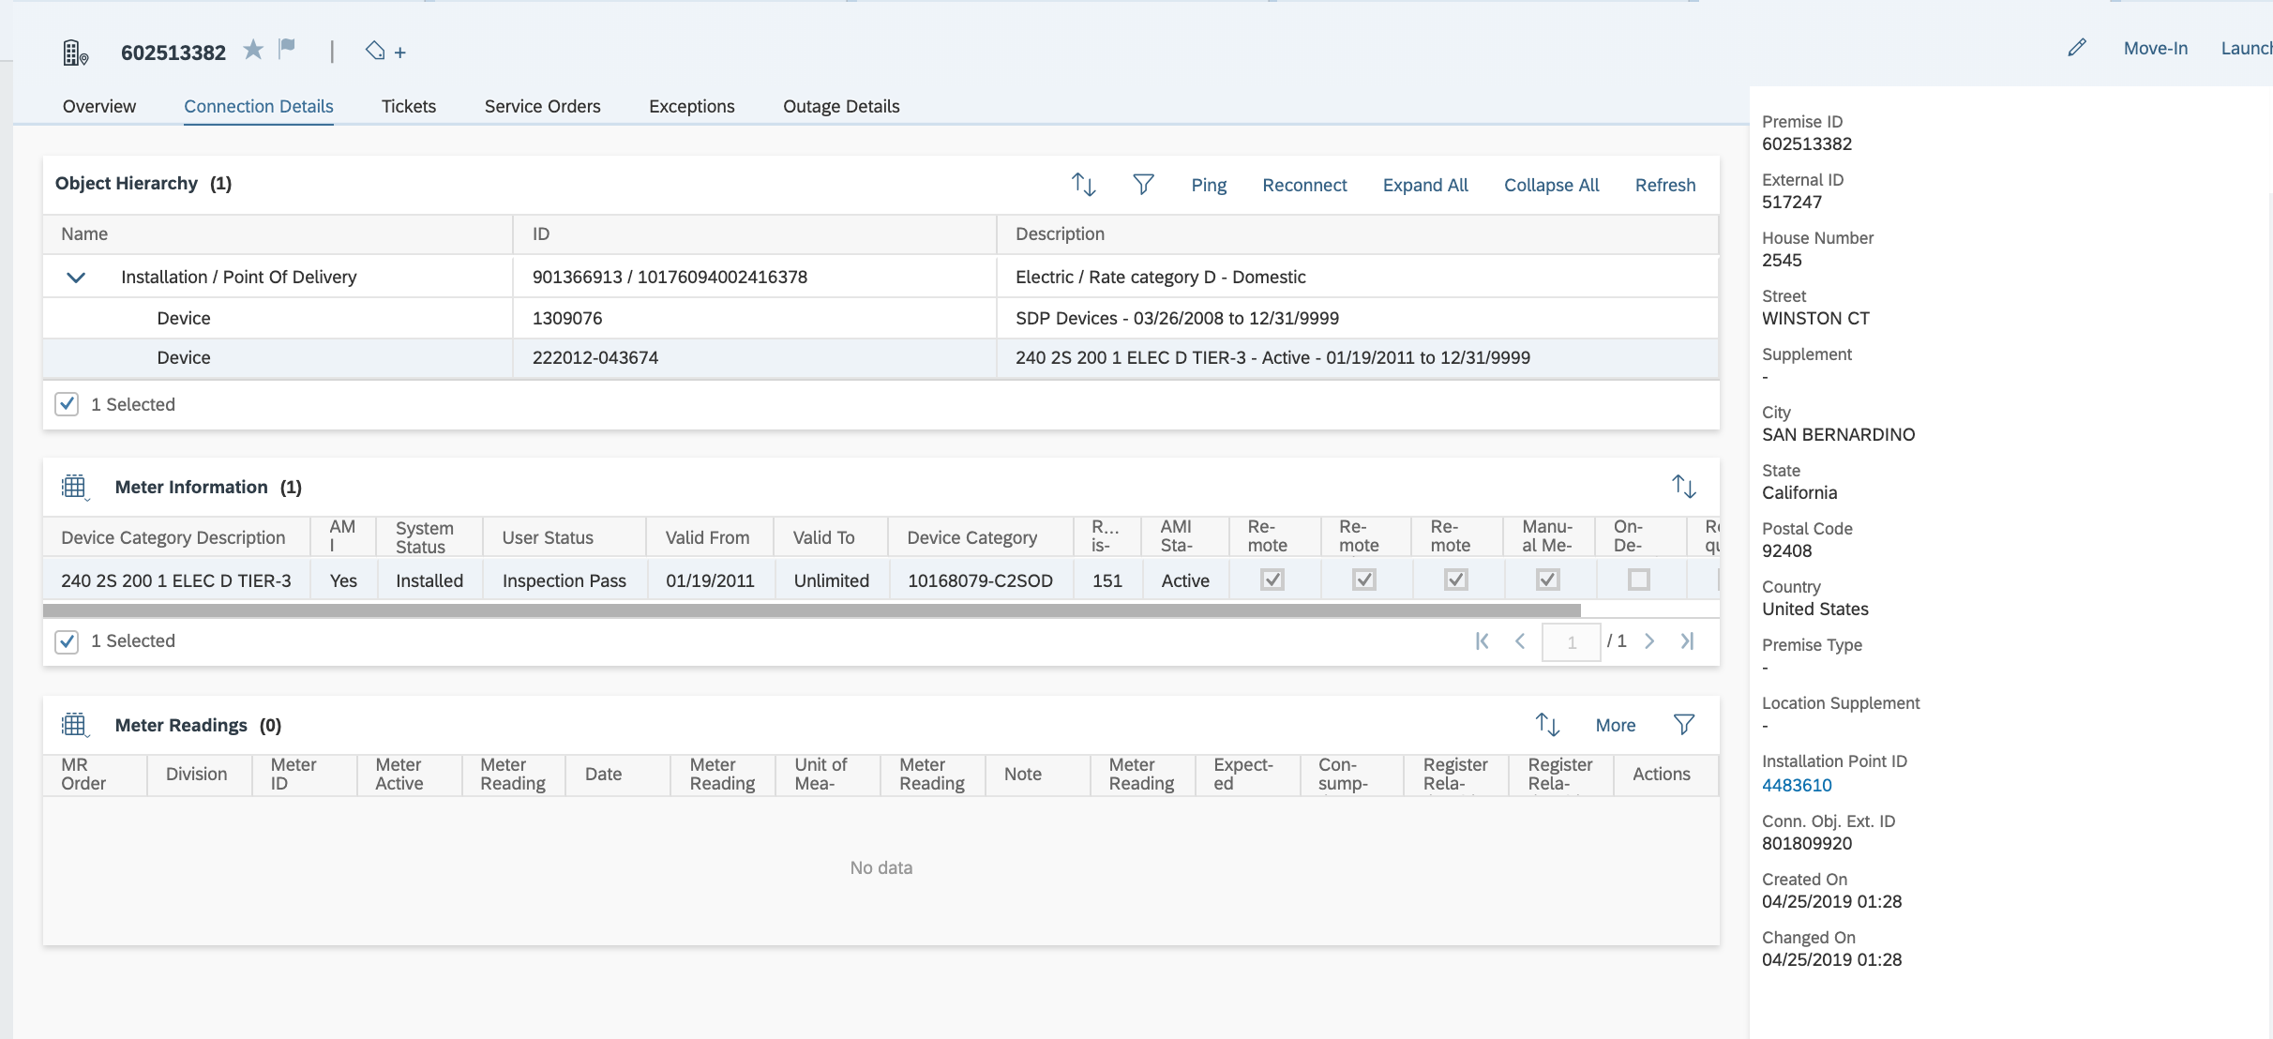
Figure 28: Connection Details

2.1.4.7 Utilities Call Center - Mash-ups and Front Office Processes
C4C offers different mechanisms to allow users to access data from external sources while using the C4C application. Depending on the third party application, the following options are available:
- Front Office Processes: A front office process (FOP) can be launched via C4C using the ‘Launch FOP’ button. This is used to launch S4/HANA transactions from C4C. This will allow front office users the ability to access the transaction they need within S4/HANA with minimal navigation as possible. The full list of configured FOP’s, refer to APSE document FOP List.
- Mash-up (URL, web service, or HTML): A mash-up allows the user to easily launch a third party application via a link or by embedding it within C4C (depends on the mash-up type and third party application). At SCE, the following mash-ups have been configured within the C4C homepage in the ‘Quick Links’ section. The URLs for each are maintained within the FOP List document.
Application | Description
SCE.COM | SPOC
iEnergy | Rebate application program
DM | Design Manager
S/4HANA | Trouble Order for Non-SCE Customer

2.1.5 Sales Cloud
The Sales Cloud module is used for sales planning, leads & opportunity management. Users with authorization will have the ability to use both Sales Cloud and Service functionality. This document will only provide an overview of this functionality, as it will be covered in detail in BPD CIM-CS-16 - Manage Leads, Opportunities & Territory.

2.1.5.1 Sales Cloud - Leads
Leads are the initial step within the sales process to record interest in a specific program or product. Leads can be created manually (Figure 29), or created via excel upload as a result of an event. Leads can be qualified directly within C4C then directly converted to an opportunity. Sales phases with mandatory activities that must be completed can be defined. This will assist in standardizing the sales process to ensure each team member is performing the required tasks. For additional information regarding the leads management process, please refer to CIM-CS-16 - Manage Leads, Opportunities & Territory.
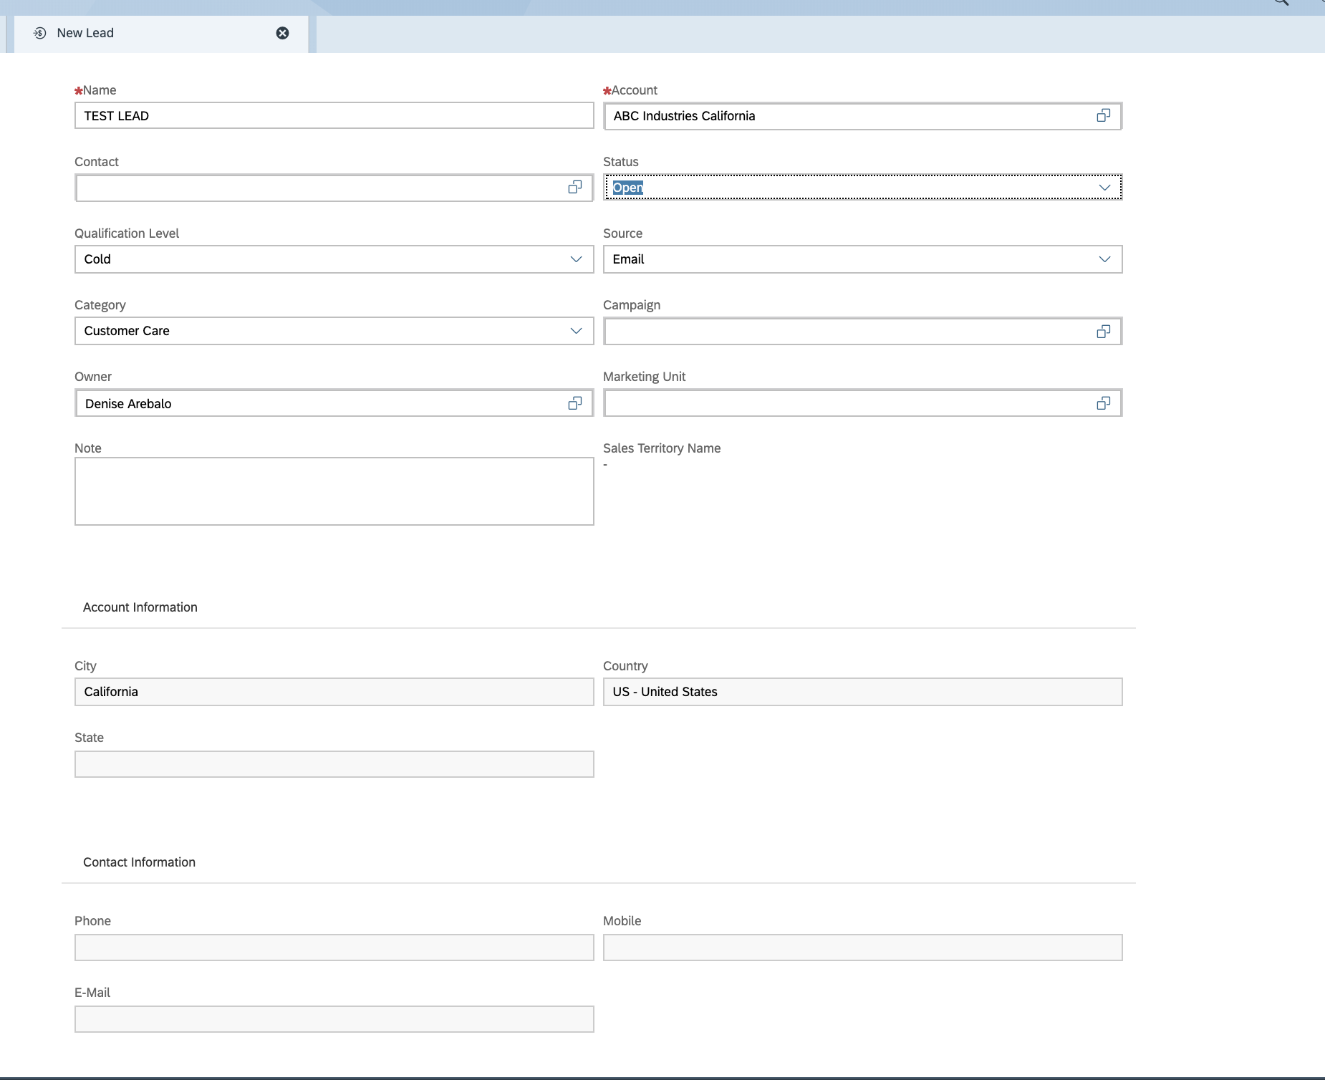
Figure 29: Leads Creation

2.1.5.2 Sales Cloud - Opportunities
Once a lead is qualified, it can be converted to an opportunity. Information from the lead will be copied to the opportunity, and the user will be able to set multiple attributes including the forecast category, source of the opportunity, probability, expected value, and whether or not it should be included in the forecast (Figure 30). For additional information regarding the opportunity management process, refer to CIM-CS-16 - Manage Leads, Opportunities & Territory.
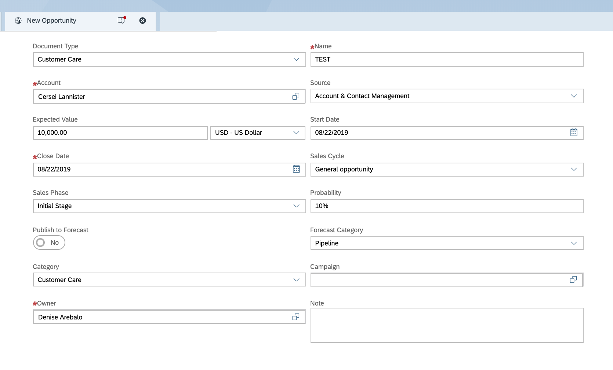
Figure 30: Creation of an Opportunity

2.1.5.3 Sales Cloud - Territory Management
Territory management is used as a mechanism to allocate a group of accounts to dedicate a resource within a sale organization or account team. Realignment runs are periodically executed to reassign accounts based on changes in both the customer account data, and potential changes in the assigned account teams. If an account is assigned it will be denoted in the customer’s account details, including their territory assignment (Figure 31). For additional information on territory management, please refer to CIM-CS-16 - Manage Leads, Opportunities & Territory.

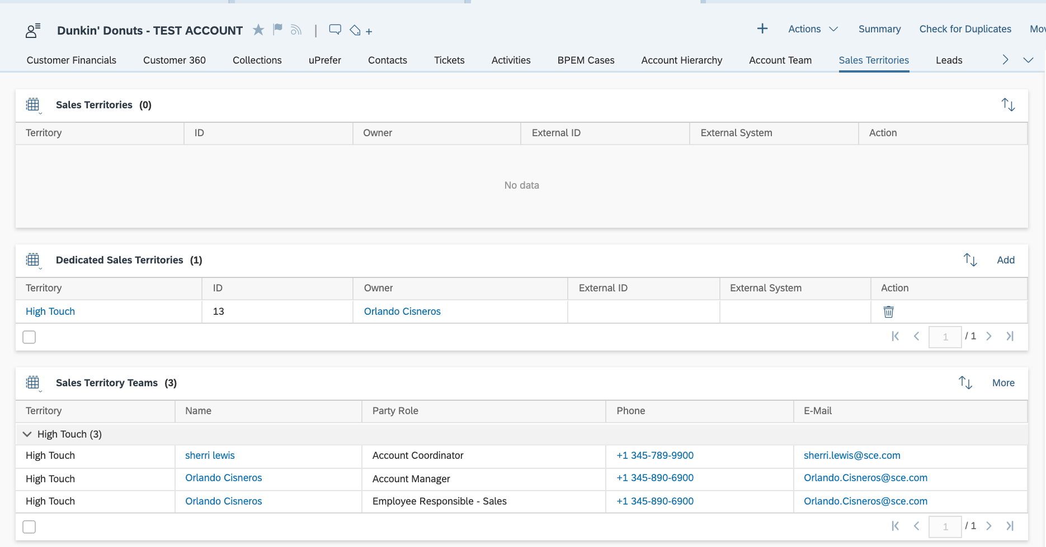
Figure 31: Territory Assignment

2.1.6 Organizational Structure and Roles
This section will discuss the business roles and organizational structure that will be configured in C4C.

2.1.6.1 Organizational Structure and Roles - Organizational Structure
SCE currently performs their employee maintenance, which includes user creation and assignment within the organization structure (role assignment) in their existing ERP system. The organization structure in C4C will need to be configured so that it is in sync with the organizational structure in the ERP system (Figure 33). Users will not be automatically created in C4C, they will require manual creation and role assignment.
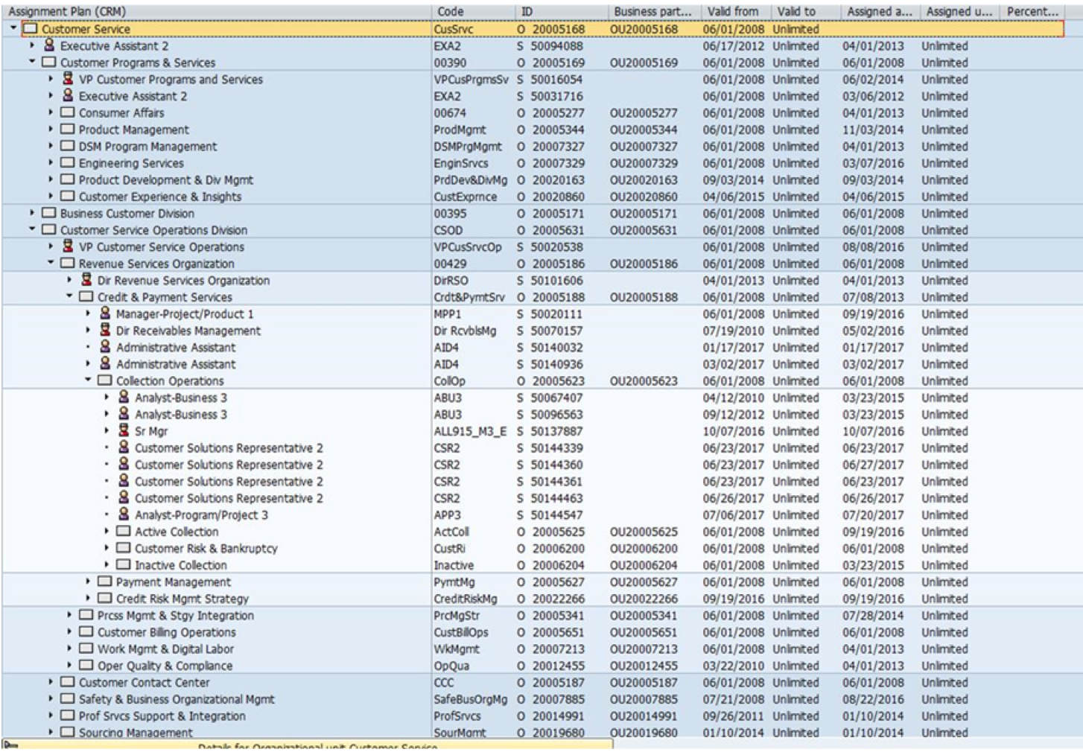
Figure 33: SCE’s Existing Organizational Structure

2.1.6.2 Organizational Structure and Roles - Roles
The roles will be owned and managed by the SCE Security team. They will be responsible for the creation of the users, in the system and assigning them the appropriate roles, which will provide the required system access. The role definition are maintained in APSE Deliverable #66 Security Access Roles and Procedures.

2.2 Process / Performance Improvement
- SAP allows for smart search capabilities and provides suggestions as the user types, similar to text prediction. It also provides a wildcard search option using an asterisk (*). Users can search by multiple criteria such as name and house/business number.
- Web-based, customer service, sales, and social networking functionality
- Provides an intuitive, Web-based user interface that is compatible with mobile devices.

2.3 Prerequisites and Inputs
- End-users have been created within both C4C and S4/HANA, and should be assigned their appropriate roles
- Master Data has been successfully loaded into both S4/HANA and C4C
- 3rd Party Integration is complete
- CPI connectivity is established successfully

2.4 General Assumptions
- Business Master Data and Technical Master Data will need to be loaded per applicable BPD
- Computer Telephony Integration (CTI) (as indicated in IVR BPD)
- Cloud Platform Integration (CPI) configuration should be complete

2.5 Business Process Hierarchy
This Business Process Hierarchy provides a listing of all scenarios/business processes, sub-processes, and SAP Transaction codes identified to support this process.
Level 1 | Level 2 | Level 3 | Level 4
Front Office and Back Office | Business Partner | Create Business Partner  Change Business Partner  Display Business Partner  Create Contract Account  Change Contract Account  Display Contract Account  Utilities 360  Utilities Financial  Utilities Rate Change  Utilities Exception  Utilities Service Order  Utilities Sales POD  Account Hierarchy | Front Office/C4C System

2.6 Process Flows

2.6.1 Process Flows

Process Flow Diagram

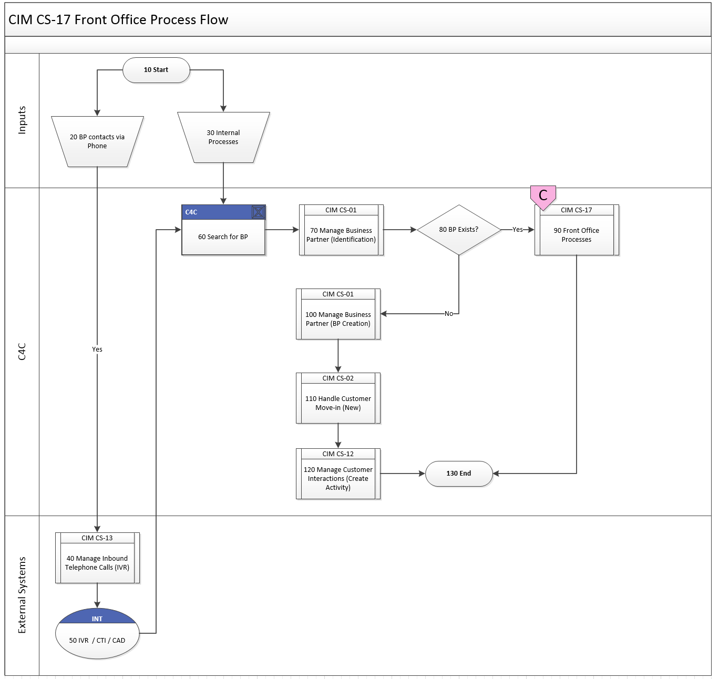

Step | Description of Step | C4C / T-Code | Role(s) | If step is relevant for a Control, add Requirement  ID
10 | Start | N/A | N/A | N/A
20 | The customer contacts SCE via inbound phone call. | N/A | N/A | N/A
30 | The customer may contact SCE via email or letter, or any other internal SCE process which requires a front office agent to review the account. | N/A | N/A | N/A
40 | The customer contacts via inbound phone, which initiates process CIM CS-13 Manage Inbound Phone Calls (CTI). | CTI | N/A | N/A
50 | Integration with IVR to authenticate the customer and provide the call center agent the caller attached data. Details are documented in CIM CS-13 Manage Inbound Phone (CTI) | N/A | N/A | N/A
60 | Search for the BP in C4C. | C4C | - Contact Center Agent Role  - Contact Center Supervisor Role  - BCD Role  - RSO Role  - IQP Role | N/A
70 | Business Partner identification is documented in CIM CS-01 Manage Business Partner. | C4C | - Contact Center Agent Role  - Contact Center Supervisor Role  - BCD Role  - RSO Role  - IQP Role | N/A
80 | Decision: Does the BP already exist?  If the BP already exists, proceed to step 90. If the BP does not exist, proceed to step 100. | C4C | - Contact Center Agent Role  - Contact Center Supervisor Role  - BCD Role  - RSO Role  - IQP Role | N/A
90 | Once the customer has been authenticated, this process will subsequently initiate any of the following processes:  - CIM-CS-01 - Business Master Data - Manage Business Partner (BP updates)  - CIM-CS-02 - Handle Customer Move-in/Out - Contract New  - CIM-CS-03 - Handle Customer Move-in/Out - Contract End  - CIM-CS-04 - Handle Trouble & Outage Contacts - Process Trouble Call  - CIM-CS-05 - Handle Request - Process Field Work Request  - CIM-CS-06 - Handle Customer Inquiries  - CIM-CS-07 - Handle Bill Inquiries  - CIM-CS-08 - Complaints, Claims, and Survey  - CIM-CS-09 - Manage Inbound Request  - CIM-CS-14 - Manage Owner Allocation  - PP-CS-02 - Program Enrollment and Delivery, De-Enrollment & Decommission Programs  - PP-CS-03 - Fulfill Customer Request  - PP-CS-04 - Manage & Support Program Operations |  | - Contact Center Agent Role  - Contact Center Supervisor Role  - BCD Role  - RSO Role  - CP&S Role  - IQP Role | N/A
100 | BP Creation is documented in CIM CS-01 Manage Business Partner. | C4C | - Contact Center Agent Role  - BCD Role | N/A
110 | Creating the customer’s contract (turn-on for start service) is documented in CIM CS-02 Handle Customer Move-in (New) | C4C | - Contact Center Agent Role  - Contact Center Supervisor Role | N/A
120 | Once the customer request is completed, the agent will need to create an activity to log the customer interaction. This is detailed in CIM CS-12 Manage Customer Interactions. | C4C | - Contact Center Agent Role  - Contact Center Supervisor Role
130 | End of Process | N/A | N/A

2.7 3rd Party and SCE Legacy System Integrations
3rd Party or SCE Legacy System Integration | Description of Integration and Required Change to 3rd Party or SCE Legacy System | Estimated Complexity of 3rd Party or SCE Legacy system change
IVR | CTI Integration

2.8 Data Elements

N/A

2.8.2 Source Systems and Data Volumes

The number of annual business transactions processed by the call center are specified below:
- 2015: 31,972,803 transactions per year
- 2016: 31,300,064 transactions per year
- 2017: 31,113,700 transactions per year
- Average: 31,462,189 transactions per year for the 3 years

2.9 Cloud for Customer (C4C) Integration

2.9.1 Processes
N/A

2.9.2 C4C Views
N/A

2.9.3 Interaction Records
N/A

2.10 Exception Management Requirements
This section outlines a high level description of each BPEM Case or other user workflow items (such as “Tickets” used by Front Office) used to route work requests between business areas. The companion document for this section which outlines the detail of each case is documented in APSE on the Exception Case Template General Document #8.
User Exception Scenario / Description | User Group | Initiated by | Work Distribution
Note: Please refer to each individual applicable BPD to view exceptions for a specific process. For example, exceptions related to Move In are documented in BPD CIM-CS-02 Handle Customer Move-in Out - Contract New

2.11 Process Risks and Mitigation
Risk Statement | Mitigation
C4C quarterly release | C4C is a cloud solution, which receives regular quarterly updates from SAP. While the updates are intended to release new functionality, the code delivered in the updates could implement changes, which could adversely impact RICEFW objects that were already developed, or cause program defects within the standard code. To mitigate this risk, the project team will closely monitor all quarterly releases for potential impacts.*
*Cloud controls framework will be defined at the enterprise level to ensure adequate design by the CM SMOO and EY.

2.12 Key Performance Indicators
The following have been identified as KPI’s at Southern California Edison, along with the means of measuring each KPI and the current measurement statistic for each KPI:
Measured KPI | Description | Measurement Method | Current Statistic
N/A

2.12.1 Key Metric Definition
The following have been identified as key metrics at Southern California Edison that require business rule for calculation:
Key Metric | Description | Business Rule | Reference
N/A

3 Controls, Regulatory Rules, and Security

Requirement  ID (from RTM) | “As-Is” Control Requirement | “To Be” Risk Statement | “To-Be” Control Activity” | Control Automation (manual, IT dependent- manual, automated | Relevant technical identifier or RICEFW reference
CONTROL-CS-1199 | Training On Communicating Accessible Authorized Payment Agency (APA) Locations (DisabRA Settlement Agreement): SCE is required to provide customer service training on communicating accessible Authorized Payment Agency (APA) locations to callers. (See DisabRA Settlement Agreement, III.B.2.f). | Noncompliance or misinterpretation with regulatory and legislative requirements may lead to misstatement of financial statements, penalties, fines and/or prosecution from governing regulatory bodies | On an annual basis, CCC management provides refresher training to all CCC Agent to provide Authorized Payment Agency (APA) location upon request of all customers, including accessibility information to the DisabRA customers. All new employees are provide this training as part of the New Hire Training. | Manual | N/A

3.1 Security Considerations
Role | Transaction Code (T-Code) | T-Code Description | Functional Restriction | Organizational Restriction
Please refer to the roles spreadsheet in section 2.1.6.2

3.2 Custom Program/Transaction Codes
Please identify any custom programs/transaction codes that need to be developed for RICEFW objects. Include RICEFW Reference ID from APSE in RICEFW Reference ID column.
The following details should be identified and captured in their respective RICEFW Functional/Technical specs
- Is the custom program executed in the batch mode or dialogue mode
- Is the custom program assigned to an authorization group
- What is the custom transaction code for the custom program
- Should there be an authorization check made against any field in the custom program/custom t-code and if so what is the custom/standard authorization object used(For example does it have to be restricted to residential vs commercial customer)
- Does the custom programs/custom t-codes have any crictial or sensitive customer information that needs extra security
Custom Table | Authorization Grp Assigned | Custom T-code for the Table | Table Access (display/update) | RICEFW Reference ID
N/A

3.3 Custom Table/Transaction Codes
Please identify any custom tables/transaction codes that need to be developed for RICEFW objects.
Include RICEFW Reference ID from APSE in RICEFW Reference ID column.
The following details should be identified and captured in their respective RICEFW Functional/Technical specs
- Are there any customer sensitive/critical Z tables created
- What is the authorization group assigned to the table
- Is it just a maintenance or display only table
- What is the Z transaction code for the custom table

Custom Table | Authorization Grp Assigned | Custom T-code for the Table | Table Access (display/update) | RICEFW Reference ID
N/A

3.4 Data Criticality and Cybersecurity Baseline Risks
Specify Data Classification /Special Handling or Regulatory Requirement  What is the classification of Data? Does it trigger any special regulations?  Please select the classification / Sensitivity of the Data. This will help us Assess the Risk associated and remediation measures if any. | <Select all that apply>  ☒ PII - Personal Identifiable Information / Privacy Law  ☐ CEII - Critical Energy Infrastructure Information  ☐ FERC SOC (Standards of Conduct)  ☐ NERC CIP Confidential  ☐ Sarbanes-Oxley (SOX) financial reporting data  ☐ SCE utility data accessible by affiliate companies (CPUC)  ☐ PCI - Payment Card Industry Compliance  ☒ Customer Information Service Request (CISR, CISR-DRP)  ☐ Other _<Please Specify>_  ☒ Internal  ☐ Public  ☒ Confidential
Please identify which business Group/Role will require access to the data and/or solution:  Please select the list of Busines Groups will have access to this Data / Process. This will help us Determine the Impact and Risk Spread. Will ensure efficient Risk mitigation measures. | <Select all that apply>  ☐ SCE Customer, Res./Comm. Customer;  ☒ SCE OU, Business Function Organization Name: CCC, BCD  ☐ Vendor  ☐ External business partner(s) & SaaS providers  ☒ External on-shore contractors  ☒ External off-shore contractors  ☐ SCE Affiliate Company Employees  ☒ SCE Employees, specify if they have Marketing Function responsibilities (e.g., ES&M)  ☐ SCE contract workers  ☐ Regulatory Agencies  ☐ Others _<Please Specify>_
How many of the SCE Customer, Employee, Vendors will use or affected by the Business Process?  To identify the Impact if services are adversely affected. | 1,000 - 10,000
How much Information/data would be processed, received or tramitted by the Business Process?
The data volume that will be utilized by this process. Helps us in determining the Impact and criticality
Number of business transactions in average?  These are the number of transactions process by the application on average. The number of transactions help in understanding criticality and Impact. | 2015:  31,972,803  2016:  31,300,064  2017:  31,113,700  Average:  31,462,189
Additional Security Consideration: | Any Cybersecurity impact in addition to SAP system security:  - Internet Facing Web Application? Yes Details: C4C is a cloud based application.  - Internet Facing Application Programming Interface? Yes.  - 3rd party Fedrated Authentication & Authorization, Single Sign On? Yes.

Technical Considerations

4.1 RICEF-W Assessment
All of the Forms, Reports, Interfaces, Conversion items, Extensions/Enhancements and Workflows (RICEF-W) that have been identified for this BPD are detailed in the tables below and will represent the totality of all RICEF-W items documented at the time of sign-off of this BPD. Any RICEF-W items that are confirmed via change control after this BPD receives final sign-off, will be managed within Southern California Edison’s APSE environment and not within this document.
Items denoted with ** have been identified as duplicate FRICEW objects.

Reports
Report Name & Description (List Requirements met by this Report) | Complexity | Reference ID
N/A

Interfaces
Interface Name & Description (List Requirements met by this Interface) | Complexity | Reference ID
N/A

Conversion
Conversion Name & Description (List Requirements met by this Conversion) | Complexity | Reference ID
N/A

Extension/Enhancements
Extension Name & Description (List Requirements met by this Extension) | Complexity | Reference ID
E-CIM-CS-17 - CA Custom Fields | Medium | 1804
E-CIM-CS-17 –Custom View for IDEX  This is to provide a view for CCA-DA customers | Complex | 1062
E-CIM-CS-17 - Consolidated Bill View | Complex | 1530
E-CIM-CS-17 - Credit Check | Complex | 1805
E-CIM-CS-17 – C4C Outage View | Complex | 1808
E-CIM-CS-17 BP Contacts in C4C | Simple | 2017
E-CIM-CS-17 Create Service Orders in C4C | Simple | 2019
E-CIM-CS-17 Rate Change Validations in C4C  Requirement - 553 - CIM-CS-02-R0003 | Medium | 2022

Forms
Form Name & Description (List Requirements met by this Form) | Complexity | Reference ID
None.

Workflows
Workflow Name & Description (List Requirements met by this Workflow) | Complexity | Reference ID
None.

IDEX Considerations
An enhancement has been identified for IDEX: 1062 - E-CIM-CS-17 - CCA DA Verification

Production System Cut-over Considerations
- C4C connectivity to S4/HANA will need to be established as a part of cutover. This includes the creation of the communication systems, communication arrangements, and configuration and deployment of Iflows within CPI.

4.6 Other Considerations
N/A

Change Management

5.1 Change Impacts
For the most current change impacts, refer to APSE Gen Doc 914 Change Impact Refresh/Executive Summaries

Change Element Short Description | Change Impact Category | Audience Group(s) | Impact | Business Effort
All transactions/orders must replicate to the backend from the front end tool. If it fails, someone must address the replication error. A new role will be required to address exceptions. SCE business users are more appropriate to work on replication issues as SCE IT may not have the authorized system functionalities to fix the data compared to business users | Job Roles (35) | CS-CSOD-CCC All, CS-CSOD-RSO All, CS-BCD-All | Low | Low
SAP releases new value-added features and upgrades for the C4C application on a pre-planned schedule. These releases will need to be tested. New features from the release will need to be communicated to users as well. | Technology | CS-CSOD-CCC All, CS-CSOD-RSO All, CS-BCD-All | High | High
SAP has different terminology between the Front office and Back office applications. (Example - Business Partner in Back-Office and Customer in Front Office) | Process (122) | CS-CSOD-RSO All;CS-CSOD-CCC All;CS-BCD-All;CS-CSOD-Consumer Affairs | Low | Low
Currently customer account numbers are 9 digits in length and begin with the number 2. In SAP, Contract Account numbers will be 12 digits in length and the leading indicator will be a 4, 5, 6 or 7 depending on the account type. An account number beginning with a 4 will be a 3rd Party Supplier account , a 5 will be a stand-alone Deposit account , a 6 will be a Collective account, a 7 will be a will be a Standard or Joint Contract . Users will be able to locate the legacy account number in the BP level. Users will need to advise customers about the new account identifiers and where to locate it on their statement in the event that they call the contact center and use their old CSS account number as a search criteria. External customers will be impacted and can drive call volume. For back office users, it may add additional AHT for account look up in the MDMS and will have an impact to CCA/DA third parties. It may also have reporting impacts as well as impacts to external vendors.  Customer Impact - Customers will need to locate their new account numbers on their bill statement as well as make any changes to their accounts that require the account number such as banking institutions, reporting needs etc. | Process;Decision Making (127) | CS-CSOD-CCC All;CS-CSOD-RSO All;Ext-Customers-All;Ext-Third Party Vendors-All;Ext-Third Party Vendors-Banks;CS-BCD-All;CS-CP&S-All;CS-CSOD-Consumer Affairs | Medium | Medium
Mailing address verification process is currently performed by third-party and this will be changed in SAP (Address verification will be done in SAP). Going from 1 month to 4 months. Concern – Increase of return mail. We need to ensure this will not impact the cost savings with USPS and Compliance. May increase operational work to handle increase of return mail and manual clean-up of addresses. It may have O&M budget implications for RSO mailing operations | Process;Regulatory/Legal;Technology (132) | CS-CSOD-CCC All;CS-CSOD-RSO All;CS-BCD-All;Compliance-All;CS-CP&S-All;CS-CSOD-Consumer Affairs | Medium | Low
SAP allows for smart search capabilities. It will provide suggestions as the agent types in more data. It can also provide a wildcard search option (using *). It also allows to search by multiple criteria such as name and house number. CSS currently does not have the functionality. The agent has to type the street name, customer name or account number as search options. As a result, searches should be quicker and provide more flexibility. | Process;Benefit/Improvement (208) | CS-CSOD-CCC All;CS-BCD-All;CS-CSOD-RSO All;CS-CSOD-Consumer Affairs | Low | Low
In SAP, there are multiple functions related to tracking of customer interactions. Users can create activity records with notes attached or an interactive free form notes field. Other users will create notes attached to BPEM cases and BP contacts notes. Currently there is only 1 notes function in CSS from the different levels. Users will need to know the difference on each of these and know when to use the proper notes or record to ensure consistency in the process | Process (241) | CS-CSOD-CCC All,CS-CSOD-RSO All,CS-CSOD-Consumer Affairs | Low | Low
Average handle time may increase in the front office due to multiple changes in the processes. Front line users will have the capability to complete more transactions from an end to end perspective as well as certain processes have more steps than as is process. Both of these can increase AHT. The ability to complete more transactions will improve customer satisfaction as well as first call resolution if agents have the ability to issue and correct more issues while they are interacting with the customer but AHT impacts associated with those calls types will need to be reviewed and reassessed. | Compensation/Performance;Culture Shift;Process;Staffing Levels(368) | CS-CSOD-CCC All; | High | High
Pending SAP Upgrade 1808 - Front office users will have visibility to single BPEM case through the life cycle of the work item. This can be used for SLA compliance or advise customer of the detailed status of the request for customer satisfaction and first call resolution. Currently users do not have detailed visibility to the life cycle of the exception. | Benefit/Improvement;Decision Making;Process;Regulatory/Legal;Compensation/Performance (496) | CS-BCD-All;CS-CP&S-All;CS-CSOD-All | High | High
DSM and Energy Savings programs process may change based on the new bolt on process integration. The lead/opportunity process will change as a result of outputs from the bolt on system. SAP front office User Interface will have an integration with the new bolt on systems. Currently DSM opportunities are created and tracked in the Legacy CRM system. | Culture Shift;Process;Technology;Benefit/Improvement (517) | CS-BCD-All;CS-CSOD-CCC-PS;CS-CSOD-CCC-EE | High | Medium
Authorized users (e.g. supervisors and managers) need to be trained on the process to ensure that roles are transferred properly/correctly if moving from one position to another position (onboarding). This needs to be trained so that employees maintain user productivity. | Decision Making;Job Roles;Process (521) | CS-All;T&D-All | High | High
The current system defaults state for drivers license to CA. In the new system agents will need to manually enter state for drivers license. | Process (952) | CS-CSOD-CCC All,CS-BCD-All | Low | Low
Currently there is a profile to indicate a Business Partner is a minor and an end date for when the person turns 18. This helps identify if the customer can be used for services In the future, the minor designation will need entered in Activities at the BP level. This information has the potential to be lost to the depth of notes in activities. Agents will need to be trained to search for this information. | Process, Decision Making (953) | CS-CSOD-CCC All;CS-CP&S-All;CS-CSOD-Consumer Affairs;CS-CSOD-RSO-Credit | Low | Low
If the BP resides in the city, CCA (Community Aggregate) is an automatic designation upon move-in. Currently the CCA opt out information is in the customer profile viewable by FO agents. In the future, agent will use FOP to access supply scenario on installation fact to view opt out information. | Process; Decision Making (954) | CS-CSOD-CCC All;CS-BCD-All;CS-CSOD-RSO All | Low | Low
Today a cut in flat rate is posted in notes. In the new system, a cut in flat identifier will be an installation fact. Pending requirements, a BPEM case will automatically be issued after a move in is submitted in a premise that is designated a cut in flat. | Process;Decision Making (956) | CS-CSOD-CCC All;CS-BCD-All;CS-CSOD-RSO All | Low | Low
Currently agents can add SSN and Tax ID in the FO screens during the move-in process. In the future, agents will create the BP, then FOP to enter SSN/Tax ID, execute the move-in. | Process (968) | CS-CSOD-CCC All;CS-BCD-All;CS-CSOD-RSO All | Medium | Medium
Today users view a change history log in CWO in view log and event history log. In C4C, users will need to view change history in service orders through FOP. Users will see the history of the system including the users who issued/updated and canceled the work order including any notes for a work order | Process;Decision Making (957) | CS-CSOD-CCC All;CS-BCD-All;CS-CSOD-RSO All | Low | Low
Legacy system provides all technical master data viewable to users. In the future there will be some technical master data in front office. If needed data is not visible the user will view through FOP to back office. | Process;Decision Making (974) | CS-CSOD-CCC All;CS-BCD-All;CS-CP&S-All | Low | Low
Front office users will access back office screens using the Front Office Process (FOP) launcher. It is a pending enhancement. The launcher creates an opportunity for users to view data and issue transactions that is not available in the front office UI (eg. installation facts, interval usage, utility tax exemption, joint billing etc.) and minimizes the need for a hand off to the back office. This creates a single sign on to the back office system from the front office. Currently CCC and BCD use one major system for most transactions, CWO and Legacy CRM respectively. Users will need to know when to use the FOP Launcher for transactions and data elements. | Culture Shift;Benefit/Improvement;Process;Decision Making (815) | CS-BCD-All;CS-CP&S-All;CS-CSOD-CCC All;CS-CSOD-Consumer Affairs | High | High
Mash up will be created to access multiple tools that the front office users will need to respond to customers' request or to complete a transaction (eg SPOC, iEnergy, GridX and Design Manager). A mash up allows the user to easily launch a 3rd party application via a link or by embedding it within C4C. Currently the primary system that CCC/GCS uses is CWO. BCD currently uses CSS and Legacy CRM for most of their customer needs. Additional training will be required for some of these systems that will be new to our agents | Decision Making;Process;Technology (1117) | CS-BCD-All;CS-CSOD-CCC All;CS-CSOD-Consumer Affairs | High | High
Currently, after completing a turn on request through SCE.com, they can also request to add the account to an existing summary billing arrangement.  In SAP, SCE.com turn ons will only allow to set up as a solo account and not as part of a Joint or Collective invoicing arrangement.  Operational Impact: Additional calls from the customer to complete their request where these were previously not received  Customer Impact: Customers will be required to contact the CCC to add their new turn on account to a Joint/Collective arrangement | Decision Making; Process; Technology; Job Roles (Negative) 1043 | CS-CSOD-RSO All;CS-CSOD-CCC All;CS-BCD-All;Ext-Customers-All | Medium | Medium
Currently users can place the turn on on hold by clicking certain check boxes that require the turn on to be held. For example, Same Party in check box, Remove meter/service checkbox, fuse up inspection, pos id investigation, no ssn information. In SAP, to place the move in “on hold” users will need to cancel the field work order and place a billing lock on the account to prevent the billing of services.  Users will need to be trained on the process to place the move in on hold and how to reverse the process so that the move in can be completed. | Process (1041) | CS-BCD-All;CS-CSOD-CCC All;CS-CSOD-Consumer Affairs;CS-CSOD-RSO All;T&D-All | Medium | Medium
Users will access Design Manager through a Mash up to create New Business service requests (SR). There is no SR/MSR process in SAP so access to DM is necessary to begin the SR/MSR process. Currently users create an SR through CSS/CWO application. It allows users to create a New Business turn on along with the SR.  Customer Impact: Customers will need to call multiple times to begin the SR process and then call again once the technical master data has been created to start the move in process. It may take multiple calls for the customer to complete the process. Service level agreements may be needed to discuss when the TMD is created so that customer facing users can provide accurate information to the customer. | Decision Making;Process;Technology (1130) | CS-BCD-All;CS-CSOD-CCC All;CS-CSOD-Consumer Affairs;CS-CSOD-RSO-CBO; Ext-Customers-All;T&D-DBL-Local Planning All;T&D-DBL-Tech Planning All;T&D-DBL-Track Planning All | Medium | High

Below is a description of each:
Change Element Short Description: Describes the ‘As-Is’ scenario and what is changing.
Change Impact Category: Determined by asking the questions below.
- Staffing Levels - Is the work effort increasing or decreasing (staffing levels), and how (e.g., task automation, new process/tasks)?
- Job Roles - Will the responsibilities, authority, or required skills for a job or job roles change? Will people be reporting to new leaders? Will managers’ responsibilities change?
- Compensation / Performance - Will the changes have such an impact on roles of an individual that merits a change in how they are compensated or how their performance will be evaluated? What behaviors are rewarded and recognized?
- Organization Structure - Is the ownership of the Process or Data changing (think departments, jobs, or roles, not individuals)?
- Decision Making - Will any of the changes impact how decisions are made, by or between, business units / departments? Who makes them, how they determine the criteria for making a change?
- Culture Shift - Will organizational value systems impact the way change happens or be impacted by the change? What are the underlying values of the organization that will directly influence the way change will be accepted and how much work will ultimately be required to ensure successful outcomes for the business?
- Location / Facilities - Will the change impact the physical location where they process is being implemented or require changes to the facilities to enable the process to be effective?
- Process - Any change to the current process (e.g. manual process becomes automatic, or vice versa)? Are there new processes being introduced or an old process being decommissioned? Is there a requirement to change an existing business rule or business policy? Will new business rule or policy needs to be introduced and enforced or complied to?
- Regulatory/ Legal - Are there any legal / regulatory requirements that might be impacted
- Technology - Are other applications impacted (e.g., going away, becoming read-only), or are there new requirements (e.g., new SW / HW, new version)
- Benefit/Improvement - Will there be an improvement or benefit to any of the stakeholders because of this change. (Be sure to include any pain points that are being alleviated)
- Other - Are there emotional implications stemming from any of these changes (think of buy-in issues or fears)
Audience Group(s): These are the affected departments, divisions etc…
Impact: The following were used to determine the impact:

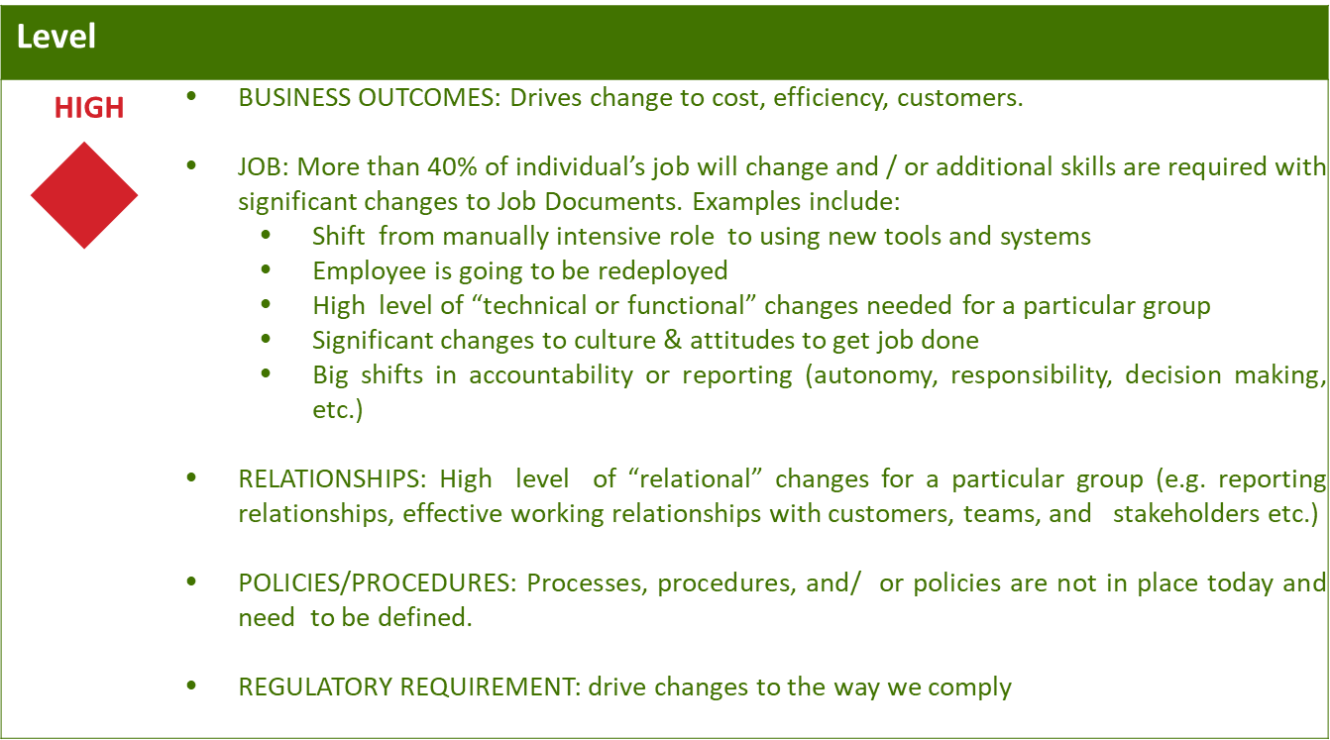
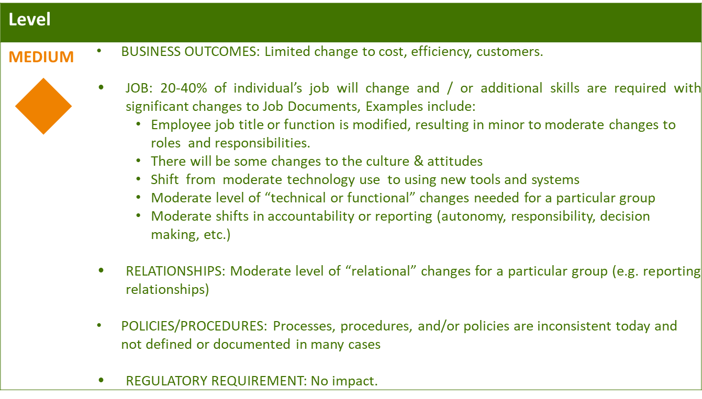
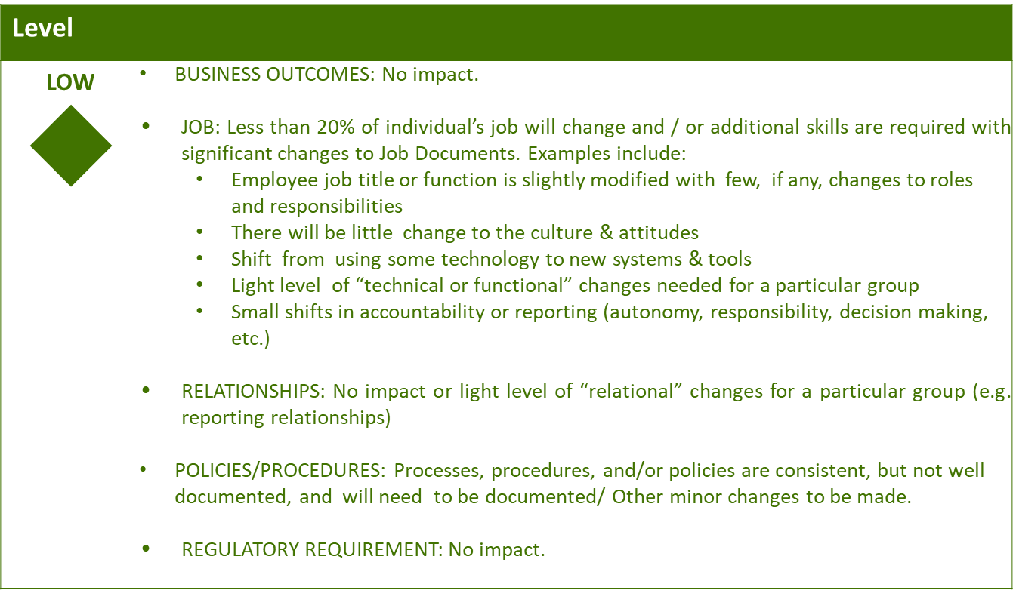

Business Effort: Initial assessment of the impact to the business High, Medium, Low

Requirements

